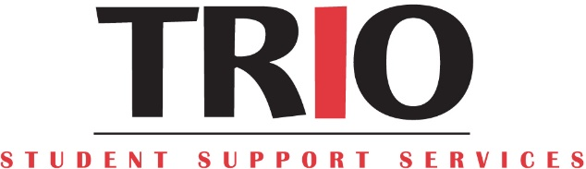

Modesto Junior College

2020-2021 Session | Workshop Evaluation

First and Last Name: ___________________________________________________

Session/Workshop Title: ____________________________________________

Session/Workshop Date: _______________________
Your College Major? ________________________________

- What specific information did you learn today?

- What part of the session/workshop was the most helpful to you?

- List at least 3 sessions/workshops/events you would like to attend in the future?

- Please share any suggestions you may have for improving this session/workshop.

Return completed form to TRIO SSS via email mjctriosss@yosemite.edu to make sure you meet credit towards your Mutual Student Agreement. Any questions please call us at (209) 575-6189.

