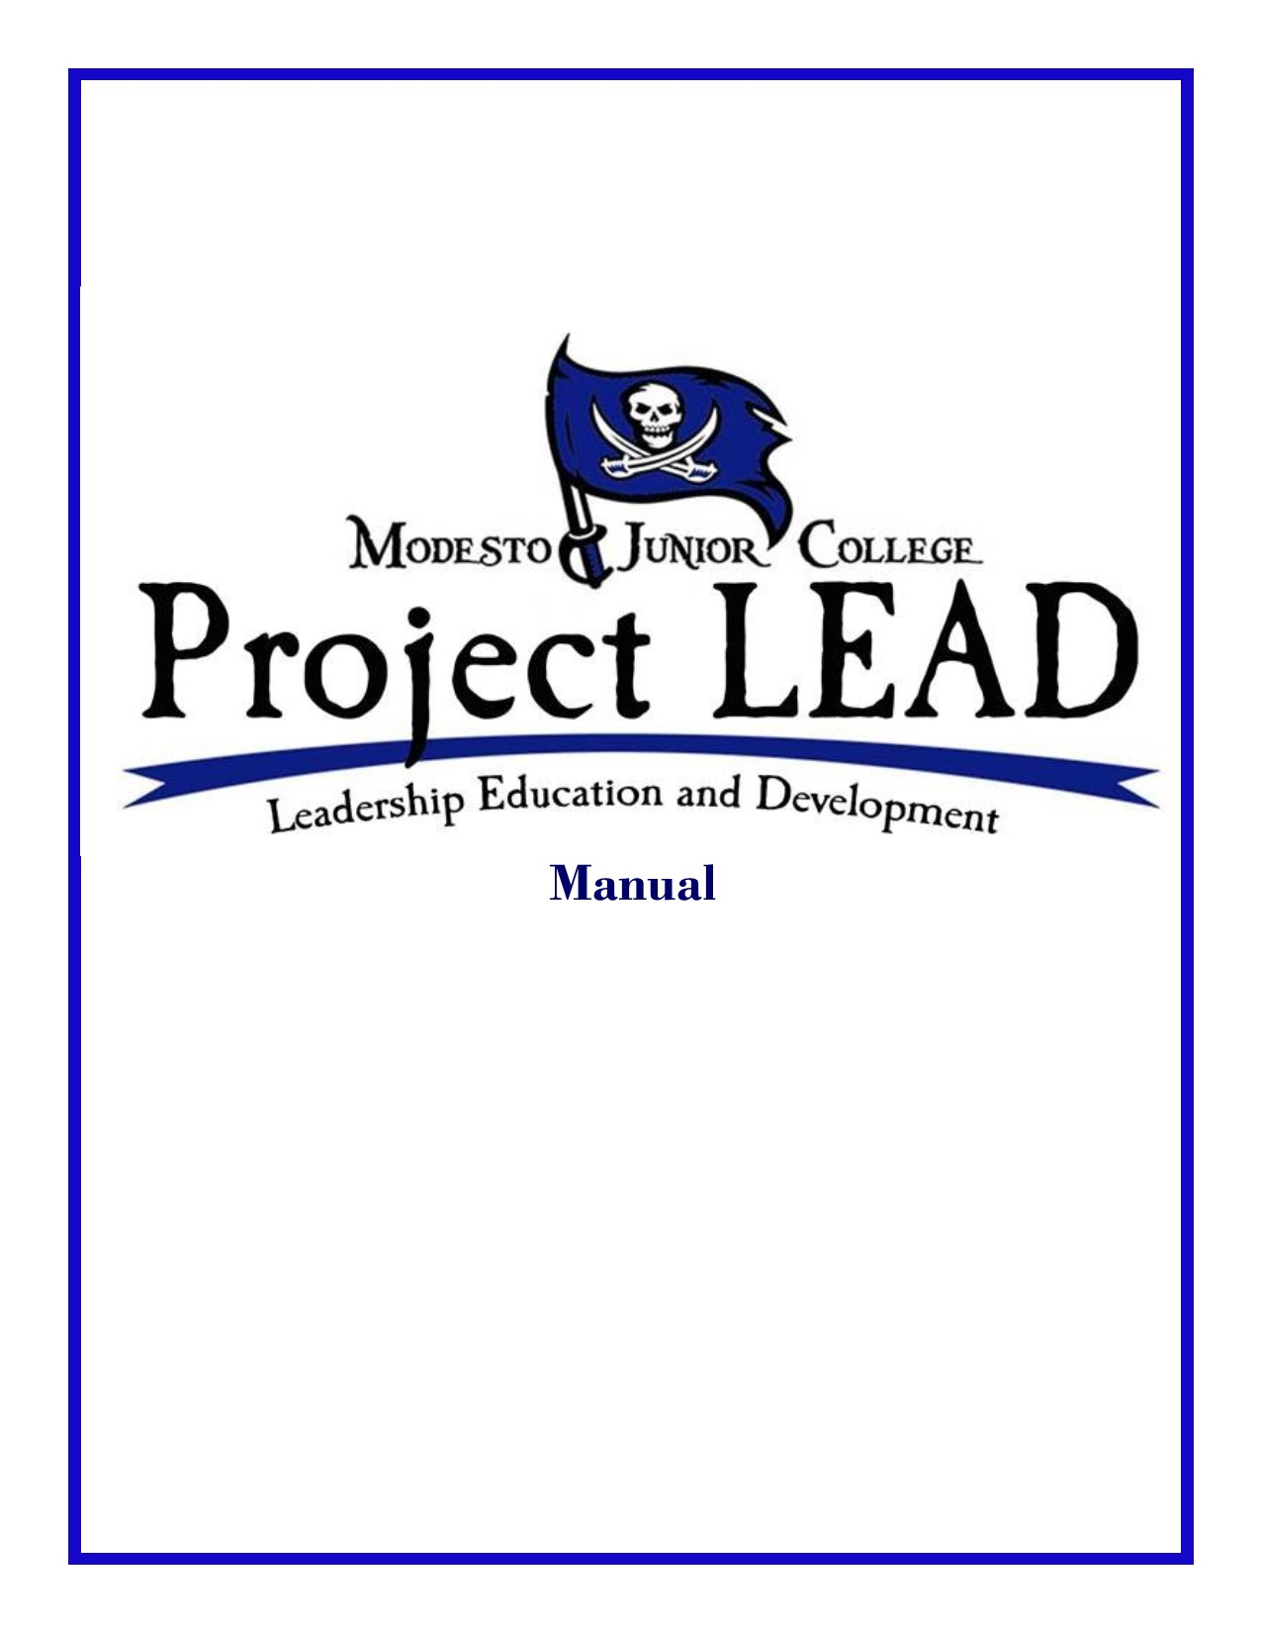

Dear Student,
Congratulations on taking a major step in your life to achieving your life long goals. President John F. Kennedy once said that “Leadership and learning are indispensable to each other”. Project LEAD is a vehicle to bring together the world of leadership and learning for Modesto Junior College students. Project LEAD was created to help students ignite their passion for leadership, service, personal growth and development. Some of you may be tempted to say “I am not a leader” or you may be referred to by others as the “leaders of tomorrow”. Leadership, in its simplest form, is the ability to influence. Each of you possess that ability. You are not the leaders of tomorrow; you are the leaders of today!!!
Your participation in this program will put you in a position to step out in to the world with more knowledge, more confidence, and an increased desire to be innovative, creative, and active on campus and in the community.
This semester long program will provide you with as much as you put into it. Students that have enjoyed the most success in Project LEAD performed in the following positive ways:
- “The best leaders are the best note takers, best askers, best learners” Tom Peters, CEO Pure Happy Life
Be an active participant in each session. This includes asking questions, taking notes, and staying focused in trainings and sessions.
- “Success is all about making connections with people”
Barack Obama, President of the United States
Reach out and make connections. This includes talking to classmates outside of program sessions, reaching out to presenters outside of sessions and making connections.
- “Procrastination is the dark side of leadership”
Laurie-Ann Murabito-Speaker, Author, Solutionist
Avoid procrastination. There will be assignments, sessions, and activities outside the scheduled sessions. Be sure to set up times and plan accordingly. Do not put off task until the last minute.
- “Ask for help not because you weak, but because you want to be strong”
Les Brown-Motivational Speaker, Author
Ask for help or clarification. This includes making sure you fully understand all the things you must do to complete the program. Asking for clarification on tasks and reaching out for help if you are falling behind.
This journey, if you put your all into it, will serve you in life far beyond the 15 weeks you are in Project LEAD. This manual has and its contents are the result of the great feedback and suggestions by Project LEAD graduates. I hope you find it useful and know that throughout this journey that myself and our whole MJC Campus Life & Student Learning team are here to help!

Best of Luck,

Alejandra Espinoza
Campus Life & Student Learning Manager
Modesto Junior College

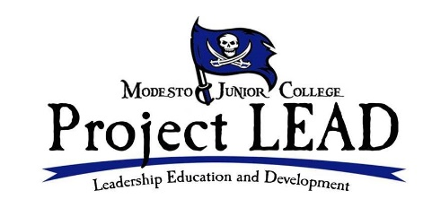

Table of Contents
Project LEAD Purpose 4
Why were you selected? 4
Participant Expectations 4
Leadership Seminars Overview 5
Seminar Schedule 5
Leadership Seminars Descriptions 6
-Conflict Resolution 6
-Communication 6
-Leadership & Beyond 6
-Modesto Junior College/ASMJC History 6
-Networking & Professionalism 6
-Service: The Need to be Involved 7
-Teamwork 7
-Time Management 7
Seminar Presenters 8
Mentoring Overview 9
Role of the Mentor 9
Role of the Mentee 10
Mentors 11
Service Projects 12
Project LEAD Graduation Requirements 12
Project LEAD Responsibility Contract 13

Project LEAD Overview

The Purpose of Project LEAD
The mission of the Project LEAD program is to provide Modesto Junior College students, enrolled in the program, a leadership framework that will encourage students to be take on leadership roles and become active participants in campus and community organizations, events and activities.
Why were you selected?
You were selected for Project LEAD because of your desire to learn, grow and evolve your leadership skills. This will require you to make an intentional effort to be physically and mentally present as well as an intentional effort to enhance current skills as well as discover and develop new skills. Only 21 students are accepted to Project LEAD.
Participant Expectations
One of the first steps to being a strong leader is the ability for one to be accountable for their own actions. This is an extra-circular program that you voluntarily applied for and as such the following are expectations of the program:
Attendance-Applicants were given a list of all program seminars and the schedule at the time of orientation. This is to help keep you organized and allow you to plan appropriately. You are expected to be at every seminar. Additionally, you are expected to be on time, meaning in your seat ready to begin prior to the listed start time of any activity.
Your schedule includes departure times for seminars that are off campus. You are expected to be ready to leave campus on time. If you are not present at the listed time, the vans will leave with without you. More than one absence will be cause for you being dropped from the Project LEAD. Project LEAD will require time outside of scheduled seminars as well, this includes meetings with mentors and preparation for service projects. You should be in attendance and on time for those activities as well. Should you anticipate you may be absence please email the Campus Life Manager at espinozaa@mjc.edu . Failure to attend may result in your being dropped from the program. If dropped from Project LEAD you may be dropped from any other program that requires your attendance here.
Program Participation- This is a program designed specifically for you with a great deal of feedback from previous graduates to further ensure student success in the program. As hard as the program works to evolve in an effort to serve students, it is equally important that students participating in the program are active in all parts of the program. This includes seminars, mentoring sessions, project planning and program communication.
During seminars you are encouraged to take notes and ask questions. Please ensure that questions pertain either to the presentation topic or the background of the presenter. Save personal questions for after the seminars. Seminar presenters are more than happy to correspond with you after the sessions.
Program Communication-With all that is expected in Project LEAD communication will be very important. Some discussions will take place before and after seminars, but some will take place outside the classroom in email threads, text messages, and phone calls. You will be expected to be a part of those methods of communication. When messages are sent out through any of these forms of communication you need to respond acknowledging that you received the correspondence.

Leadership Seminars Overview
Leadership seminars are designed to expose you to a variety of leadership topics that will be applicable to you as you progress along your leadership journey. Each presenter is a notable member of the community and are volunteering their time to help Project LEAD students further their knowledge and experiences.
Leadership Seminar Schedule
Date Topic/Location/Times Presenter
January 15 Project LEAD Orientation Campus Life Staff
2:00pm-3:30pm Modesto Junior College
On Campus: CAT 108

January 24 MJC History & Structure Dr. George Boodrookas
2:00pm-4:00pm Dean of Advancement
On Campus: CAT 101 Modesto Junior College

January 31 Communication Adrenna Alkhas
2:00pm-4:00pm Marketing & Communications Director
CAT 101 Stanislaus County

February 28 Teamwork Lieutenant Steven Stanfield
Off Campus: Depart 1:30pm Modesto Police Department
Meet in Front of Student Center City of Modesto

March 13 Networking & Professionalism Alejandra Espinoza
2:00pm-4:00pm Campus Life & Student Learning Manager
On Campus: CAT 213 Modesto Junior College

March 27 Time Management & Planning Laura Ward
Off Campus: Depart 1:30pm CEO/President
Meet in Front of Student Center Ward Promotional Marketing

April 3 Conflict Resolution Amy Vickery
Off Campus: Depart 1:00pm Public Information Officer
Meet in Front of Student Center Stanislaus County

April 10 Service: The Need to Be Involved Lynn Dickerson
Off Campus: Depart 1:30pm CEO
Meet in Front of Student Center Gallo Center for the Arts

April 22 5th Annual Campus Life Gala Campus Life & Student Learning
5:3pm-8pm Modesto Junior College
On Campus: MSR West Campus

Project LEAD Leadership Seminars Descriptions
-Conflict Resolution
“Every problem has a gift for you in its hands” – Richard Bach, Author

It is rare on our journey in life to be able to avoid conflict. There are some individuals that live for conflict, enjoy the rush, and are in full alpha mode when conflict arises. Then there are those who completely shy away from any form of conflict. They find it to be an out of body experience that they want no part of. Neither extreme is ideal for leading. If you are leading, then conflict is inevitable. This seminar is designed to help you be able to identify conflict and be able to strategize ways to deal with conflict.
-Communication

"The art of communication is the language of leadership”- James Humes, Author

One the leading causes to problems in any relationship, business venture, or activity is the breakdown of communication. Having the ability to effectively communicate is sure to lead you on successful ventures throughout your personal and professional life. This seminar is designed to identify positive and negative forms of communication and how to identify some best practices to being an effective communicator.
-Leadership & Beyond
“If you are going to achieve excellence in big things, you develop the habit in little matters”-Gen. Colin Powell, Former US Secretary of State

As you move forward on your journey in Project LEAD you will learn a whole new set of tools as well as develop existing ones. It is important for any leader to be able to identify what are their skills sets and how to use them. This seminar is designed to give a review of all the Project LEAD seminars and showcase how to apply the skills learned to your everyday life.
-Modesto Junior College History & Structure
“A people without the knowledge of their past history, origin, and culture is like a tree without roots”-Marcus Garvey, Political Leader

It has often been said that if we don’t know where we come from how can we know where we are going. Each year, thousands of students attend Modesto Junior College but few understand the school they are attending or the student groups that exist. This seminar is designed to teach you the history of Modesto Junior College, its structure and the YCCD/MJC leadership.
-Networking & Professionalism
“It’s the people we hardly know, and not our closest friends, who will improve our lives most dramatically”-Meg Jay, Author

One of the keys to moving forward with our goals is to connect with people who can help us achieve our goals and enhance the journey. Additionally, understanding what is professional in a professional world. This seminar speaks to how to network with our peers and role models. Additionally, this seminar will speak to what is appropriate in certain professional settings and what is not.

-Service the Need to be Involved
“We make a living by what we give, but we make a life by what we give”-Winston Churchill, Former United Kingdom Prime Minister

From the world’s biggest companies to the world’s biggest leaders, from the poorest of neighborhoods to the wealthiest, there has always been a call to serve. Whether through the donation of money or the donation of time for centuries leadership has been associated with service. This seminar is designed to teach you the importance of service and how and why it is associated with leadership.
-Teamwork
"I suppose leadership at one time meant muscles; but today it means getting along with people." --Mahatma Gandhi, Leader Indian Independence Movement

Getting a group of people to work together towards a common goal is a challenge and an opportunity for all leaders. The leaders that are successful at guiding others will be the leader that enjoys the greatest overall success. This seminar is designed to identify what teamwork is, why it is important, and how can you be the one to lead a team.
-Time Management
“By failing to prepare, you are preparing to fail”-Benjamin Franklin, U.S. Founding Father

You will often hear the statement “I don’t have time” uttered by people trying to accomplish their goals. When many speak of leadership time management is often at the bottom of the list despite being perhaps the most important tool a leader can possess. This seminar is designed to teach you the importance of time management and how mastering this skill will pave the way for leadership success.

Seminar Behavior
Students participating in Project LEAD should adhere to all YCCD/MJC policies and procedures. Project LEAD students should have their binders at each seminar, be prepared to take notes, and should be active participants in the session. This includes paying attention and asking questions.

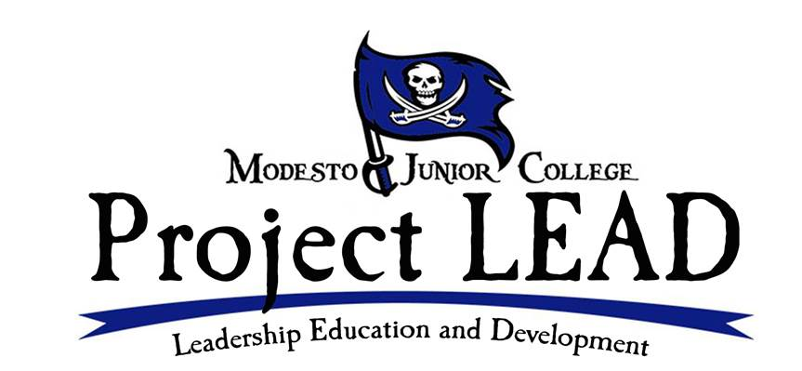
Seminar Presenters

PICTURE NOT AVAILABLE

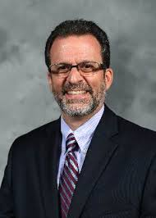
.

Dr. George Boodrookas
Dean of Advancement
boodrookasg@mjc.edu
Seminar: MJC History & Structure
Steven Stanfield
Lieutenant
Modesto Police Department stanfields@modestopd.com Seminar: Teamwork
Adrenna Alkhas
Marketing & Communications Director
Stanislaus County
adrennab@gmail.com
Seminar: Communication

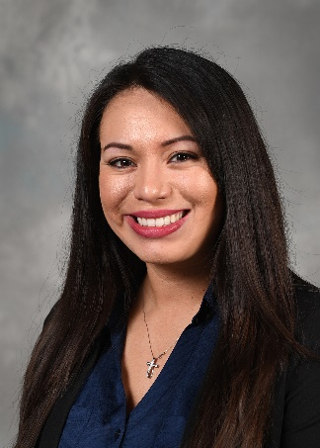

Laura Ward
CEO/President of Ward Promotional Marketing Solutions
laura@wardpromotional.com
Seminar: Time Management & Planning
Lynn Dickerson
CEO
Gallo Center for the Arts
ldickerson@galloarts.org Seminar: Service: The Need to Be Involved
Amy Vickery
Public Information Officer Stanislaus County vikerya@stancounty.com Seminar: Conflict Resolution
Alejandra Espinoza
Campus Life & Student Learning Manager
espinozaa@mjc.edu
Seminar: Networking & Professionalism

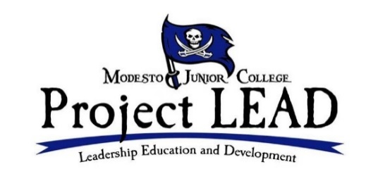

Mentoring Overview
In leadership we rise on the shoulders of those who lift us up. Every great leader has a trusted mentor(s) that they can turn to for guidance. The mentoring component of Project LEAD is designed to connect you with a mentor at Modesto Junior College. Project LEAD mentors are people that have achieved both personal and professional success.

Role of the Mentor
The role of a Project LEAD mentor is to guide you personally and professionally towards your leadership goals and guide you on your journey. Working with a mentor can be an invaluable experience for you and your mentor. You are likely to learn new things about yourself and that will help them move towards your goals. But to make the relationship work, each party needs to understand the role they play.
The role of a mentor is:
An advisor or coach: provide advice, guidance, and feedback; share their experience and expertise as appropriate; act as a sounding board for ideas and action plans. Mentors will offer encouragement and support to try new things; help mentees move out their comfort zones; celebrate successes; help mentees understand when things do not go as planned what steps might be taken.
Mentors help identify resources that will help mentees with personal development and growth, such as recommending books, workshops, or other learning tools; encourage mentees to join networking organizations or introduce them to new ideas. The role of mentor in Project LEAD is not one of a professional counselor or therapist. If a Project LEAD student is in need of professional counseling or therapeutic help, a mentor can connect the student to on and off campus resources.
Mentors should do their best to keep appointments with mentee. If unable to keep appointment, mentor should give mentee advance notice.
Mentors sign off on Project LEAD paperwork for each mentoring session. Mentors should not sign in advance of any appointments, nor should mentors sign for any appointments that did not take place.

Role of the Mentee
The role of a mentee is:
To identify initial learning goals and measures of success for the mentoring relationship. Be open to and seek for feedback. Mentees should take an active role in their own learning and help drive the process. Mentees need to follow through on commitments and take informed risks as they try new options and behaviors in support of goals.
Mentees should schedule three appointments with mentor. It is advised to schedule all three appointments right away as mentor’s schedule will fill quickly. You are encouraged to schedule an appointments a month a part. Mentees should do their best to keep appointments with mentor. If unable to keep appointment mentor should give mentor advance notice.
Mentees are trained in the Project LEAD orientation how to interact in mentoring sessions. This includes coming prepared with questions, following up on advice given by mentors, and engaging in each session. Behaviors that mentees should avoid are missing mentoring sessions, being late, not being prepared.
Mentees should have their mentor signature sheets with them at each session. Signature sheets are due at the beginning of Project LEAD seminars on the following dates:
Appointment 1 February 7
Appointment 2 March 13
Appointment 3 April 10

Mentors
Project LEAD selects mentors for the program that are committed to helping guide students in developing their leadership skills and potential. Mentors are members of the MJC Leadership team who have volunteered their time to work with our students.
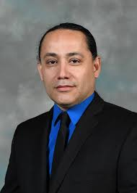
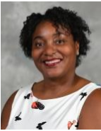
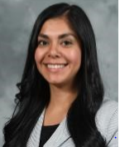
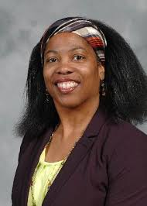

Amy Yribarren
Director of Health Services
yribarrena@mjc.edu
Dejeune Shelton
Director of Career Services
sheltondmjc.edu
Arnold Chavez
Director of Great Valley Musuem
chavezaa@mjc.edu

Pedro Mendez
Dean of Technical Ed.
Mendezp@mjc.edu
Angelica Guzman
Director of Enrollment Services
guzmana@mjc.edu
Dr. Jacquelyn Forte
Director of Student Services
fortej@mjc.edu
Dr. George Boodrookas
Dean of Advancement
boodrookasg@mjc.edu

Project LEAD Service Projects
One of the keys to becoming a stronger leader is having the ability to practice leadership. The Project LEAD service project combines all the skills learned in the program. In Project LEAD you will have the opportunity to practice your leadership skills through the completion of a service project. This is a mandatory part of the program.
Community Project
Students of Project LEAD will participate in helping the homeless in Modesto. Project LEAD students will prepare meals that will be distributed to homeless people in the Modesto area. The service project will be completed on Friday, March 27. The schedule is as follows:

9:00am-10:00am Prepare Meals
10:00am-12:30pm Meal Distribution at local parks
12:00pm-1:00pm Project LEAD lunch
1:00pm-1:30pm Break
1:30pm Leave for Project LEAD seminar

Project LEAD Requirements for Graduation
The following must be complete by April 10th in order to graduate from the Project LEAD program:
- Must have attended all Leadership Seminars and score an 80% on the post seminar questions.
- You must have completed three mentoring sessions by April 10th.
- You must complete Project LEAD service project.
Failure to complete these items will make you ineligible for graduation from Project LEAD.

Project LEAD Recognition
Upon entering the Project LEAD Program students will receive a Project LEAD t-shirt and this manual. Students who successfully complete all the requirements of the program will be recognized at the Campus Life Gala on April 22, 2020. Additionally, you will receive a certificate of completion.

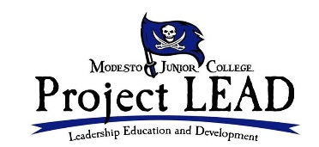

Program Responsibility Contract
As a student in Project LEAD I fully understand and agree to all requirements of the program including the following:
- Be on time for each session. I have received multiple copies of the program schedule, including the copy in the manual. I understand for off campus seminars I am to be in front of the East Campus Student Center ready to leave by 1:30pm.

- To refrain from any disruptive behavior such as talking to others during seminars when not permitted or being on my cell phone.

- Be prepared for each seminar. This means I have my manual, writing utensil, and something to take notes with.

- To schedule my three appointments with my mentor the same day of the orientation.

- To be prepared for my session with my mentor using the mentor/mentee training I received in the Project LEAD Orientation. This includes being on time, having something to take notes with, having prepared questions and topics, following up on items mentees ask me to follow up on.

- To have in my possession my mentoring signature slip at each session. I understand I must submit these on the following dates: Appointment 1-February 7, Appointment 2-March 13, Appointment 3-April 10.

- Communicate with Campus Life staff. If I am having troubles, don’t understand something, or need assistance with anything preventing me from being successful in the program I will contact the staff for assistance.

- Attend and participate in the Project LEAD service project.

- I understand to successfully complete the program I must attend all seminars, complete 3 mentoring sessions by the required dates, and complete the service project. If I do not complete any of these parts of the program, I will not graduate the program.

__________________________________ __________________________________
Participant Name (Print) Participant Signature

__________________________________
Date

