2021- 2022
Nomination Packet

ASMJC Elections 2021
Due: Friday, March 5th, 2021 by 5pm
Submit application to Campus Life & Student Learning Manager, Alejandra Espinoza at espinozaa@mjc.edu

Greetings potential ASMJC candidates,

Congratulations on taking a significant step in your growth as a leader. Being a part of the Associated Students of Modesto Junior College (ASMJC) will be one of the most enlightening, rewarding, and life-changing experiences that you will be part of.

Please understand that as a member of ASMJC the many responsibilities will absorb a great deal of your time. One of the first things to learn and develop are your time management skills. Do not let the commitment deter you. There will be various challenges that will arise along the way, but you will be given the tools and support to grow and prosper. We also have an amazing and caring staff that will walk with you on this journey. You will never be alone in this experience, as you will have a team to lean on.

Our students are our main priority, and we are here to serve our students in a multitude of ways. The impact you will make on this campus will last way beyond your years here. The bonds you will make with fellow officers and students, the knowledge you will gain, and the leadership experience all in serving your fellow students will be very rewarding. The lessons you will learn, and the leadership skills you develop will go with you throughout life.

I wish you the best of luck in running for office. I will leave you with one piece of advice: You will get out of this what you put into it.

Please let me or our Campus Life & Student Learning staff know if you have any questions.

Jennifer Novoa
ASMJC President
ASMJC Elections Chair

ASMJC Elections TimeLine – 2021

January 18 – March 5, 2021: Nomination Period – Application Available
www.mjc.edu/campuslife/asmjc
March 5, 2021: Last Day to Turn in Application for Candidacy
Application must be turned in to Alejandra Espinoza at espinozaa@mjc.edu by 5pm.

March 8 - 12 Mandatory Candidate Briefings
Must attend one.
Zoom links will be sent to student email.
-Monday, March 8th @ 9am
-Tuesday, March 9th @ 11am
-Wednesday, March 10th @ 2pm
-Thursday, March 11th @ 4pm
-Friday, March 12th @ 12pm
March 6 – April 5 Campaigning period
April 5, 2021 Voting, Via Survey Monkey
Check student email for ballot
April 6, 2021 Voting, Via Survey Monkey
Check student email for ballot
April 7, 2021 Elections Results announced
April 16, 2021 Student Senate meeting-election certification

OVERVIEW OF POSITIONS
ASMJC President
ASMJC Vice President
ASMJC Director of Political Development
ASMJC Director of Student Relations
ASMJC Secretary
ASMJC Senator

Overview of Positions
Executive Officers
President
- Prepares the agenda for, and presides over, the Student Senate meetings.
- Represents ASMJC, and the Student Senate, when requested and required.
- Reports on ASMJC activities, events, and conferences to the YCCD Board of Trustees and other College-Wide Committees.
- Fills any vacancies on the Student Senate or Executive Council.
- Makes appointments to Standing Committees, as well as ensures the full participation of the students they appoint.
- Serve on one (1) College-Wide Committee, if possible
- Holds a minimum of ten (10) office hours per week.
President’s Mandatory Commitments:
*due to COVID – 19 and social distance learning dates and events are subject to change
  - Every 2nd Wednesday of the month
  - Summer Training every Monday in Summer
  - Swearing In August 12, 2021 at 3pm
  - Summer Retreat - July 22
  - ASMJC Senate Meetings 1st and 3rd Friday of the month 3-5pm
  - ASMJC Executive Council meetings 1st and 3rd Friday of the month 1-2pm
  - Homecoming Football
  - Homecoming Basketball
  - Fall Cram Night
  - Spring Cram Night
  - Winter Retreat – December 16
  - Dr. Martin Luther King Commemoration
  - African American Education Conference
  - Hispanic Education Conference
  - Pride Education Conference
  - Campus Life Gala
  - MJC Graduation Luncheon
  - MJC Graduation 2021

Vice President
- Prepares the agenda for, and presides over, the Executive Council meetings.
- Represents the Executive Council when requested and required.
- Responsible for the recruitment of candidates to vacant positions on the Executive Council, Student Senate and Standing Committees, and providing recommendations to the President and Student Senate.
- Provides monthly accountability reports of Executive Officers and Student Senators. Serve on one (1) College-Wide Committee, if possible.
- Holds a minimum of ten (10) office hours per week.
Vice President’s Mandatory Commitments
*due to COVID – 19 and social distance learning dates and events are subject to change
  - Summer Training every Monday in Summer
  - Swearing In August 12 at 3pm
  - Summer Retreat dates- July 22
  - ASMJC Senate Meetings 1st and 3rd Friday of the month at 3-5pm
  - ASMJC Executive Council meetings 1st and 3rd Friday of the month 1-2pm
  - Homecoming Football
  - Homecoming Basketball
  - Fall Cram Night
  - Spring Cram Night
  - Winter Retreat – December 16
  - Dr. Martin Luther King Commemoration
  - African American Education Conference
  - Hispanic Education Conference
  - Pride Education Conference
  - Campus Life Gala
  - MJC Graduation Luncheon
  - MJC Graduation 2019

Director of Political Development
- The Director of Political Development or his/her designee shall serve as the Chair of the Political Development Committee and shall prepare the agenda for the meetings at which he/she presides.
- The Director of Political Development shall represent the Political Development Committee at times and places where such representation is required and shall prepare and present reports of Political Development Committee activities to the Student Senate.
- The Director of Political Development shall be required to hold and run ASMJC elections and at least one (1) political forum per school year.
- The Director of Political Development shall be responsible for researching and providing updates on federal, state, or local legislation that may have a significant impact on students.
- The Director of Political Development shall be responsible for advising the Student Senate on all matters pertaining to legislation.
Director of Political Development’s Mandatory Commitments:
*due to COVID – 19 and social distance learning dates and events are subject to change
  - Summer Training every Monday in Summer
  - Swearing In August 12 at 3pm
  - Summer Retreat - July 22
  - ASMJC Senate Meetings 1st and 3rd Friday of the month at 3-5pm
  - ASMJC Executive Council meetings 1st and 3rd Friday of the month 1-2pm
  - Homecoming Football
  - Homecoming Basketball
  - Fall Cram Night
  - Spring Cram Night
  - ASMJC Fall Town Hall
  - ASMJC Spring Town Hall
  - Winter Retreat – Dec 16
  - Dr. Martin Luther King Commemoration
  - African American Education Conference
  - Hispanic Education Conference
  - Pride Education Conference
  - 2022 Elections
  - Campus Life Gala
  - MJC Graduation Luncheon
  - MJC Graduation 2021

Director of Student Relations
- The Director of Student Relations or his/her designee shall serve as the Chair of the Student Relations Committee and shall prepare the agendas for the meetings at which he/she presides.
- The Director of Student Relations shall be required to represent the Student Relations Committee at times and places where such representation is required.
- The Director of Student Relations shall be responsible for maintaining communications with the student body about upcoming ASMJC events.
- The Director of Student Relations shall provide the students and the media with press releases, as well as supervise any media that is distributed to the student body by ASMJC, with the approval of the Student Senate.
- The Director of Student Relations shall conduct surveys within the student body for the purpose of providing ASMJC with direction in its functions.
- The Director of Student Relations shall be a liaison to the Inter-Club Council as a non-voting member.
- The Director of Student Relations shall be responsible for advising the Student Senate on all matters pertaining to student relations.
Director of Student Relations’ Mandatory Commitments
*due to COVID – 19 and social distance learning dates and events are subject to change
  - Summer Training every Monday in Summer
  - Swearing In August 12 at 3pm
  - Summer Retreat – July 22
  - ASMJC Senate Meetings 1st and 3rd Friday of the month at 3-5pm
  - ASMJC Executive Council meetings 1st and 3rd Friday of the month 1-2pm
  - Homecoming Football
  - Homecoming Basketball
  - Fall Cram Night
  - Spring Cram Night
  - Winter Retreat – December 16
  - Dr. Martin Luther King Commemoration
  - African American Education Conference
  - Hispanic Education Conference
  - Pride Education Conference
  - Campus Life Gala
  - MJC Graduation Luncheon
  - MJC Graduation 2021

Secretary
- The Secretary shall take minutes at meetings of the Executive Council, and shall ensure the distribution of those minutes to each member before each Executive Council meeting.
- The Secretary shall take minutes at all meetings of the Student Senate, and shall ensure the distribution of the minutes and all other supporting documents, including ASMJC financial reports, to each member before each Student Senate meeting.
- The Secretary shall be responsible for maintaining all documents pertaining to ASMJC.
- The Secretary shall assist the President in the execution of his/her duties.

Secretary’s Mandatory Commitments:
*due to COVID – 19 and social distance learning dates and events are subject to change
  - Summer Training every Monday in Summer
  - Swearing In August 12 at 3pm
  - Summer Retreat – July 22
  - ASMJC Senate Meetings 1st and 3rd Friday of the month at 3-5pm
  - ASMJC Executive Council meetings 1st and 3rd Friday of the month 1-2pm
  - Homecoming Football
  - Homecoming Basketball
  - Fall Cram Night
  - Spring Cram Night
  - Winter Retreat – December 16
  - Dr. Martin Luther King Commemoration
  - African American Education Conference
  - Hispanic Education Conference
  - Pride Education Conference
  - Campus Life Gala
  - MJC Graduation Luncheon
  - MJC Graduation 2021
Senator
  - Assist in the planning, evaluation, collaboration, and progression of all of ASMJC’s political development and student relations
  - Complete an annual project that will benefit the membership of ASMJC or the surrounding community
  - Serve on one (1) standing committee (Political Development or Student Relations)
  - Serve on one (1) College-Wide Committee
  - Hold a minimum of five (5) office hours per week
Senator’s Mandatory Commitments

*due to COVID – 19 and social distance learning dates and events are subject to change
  - Summer Training every Monday in Summer
  - Swearing In August 12 at 3pm
  - Summer Retreat – July 22
  - ASMJC Senate Meetings 1st and 3rd Friday of the month at 3-5pm
  - ASMJC Executive Council meetings 1st and 3rd Friday of the month 1-2pm
  - Homecoming Football
  - Homecoming Basketball
  - Fall Cram Night
  - Spring Cram Night
  - Winter Retreat – December 16
  - Dr. Martin Luther King Commemoration
  - African American Education Conference
  - Hispanic Education Conference
  - Pride Education Conference
  - Campus Life Gala
  - MJC Graduation Luncheon
  - MJC Graduation 2021

CANDIDATE ELIGIBILITY

Being a member of student leadership is a major time commitment that will require strong time management, sacrifice, and a willingness to serve and participate. Students are expected to be able to maintain their studies while participating in student government. To be in student government means to lead by example!

Per the Bylaws of ASMJC candidates must meet the following eligibility requirements

Article VI, Section 1, Clause C
A member of Student Government at MJC must not be on Academic Probation, nor have been found responsible for a violation of the Student Code of Conduct at the time of application or during their term of office.

Article VI, Section 1, Clause D
A member of Student Government at MJC must be currently enrolled in a minimum of nine (9) units during the Fall and Spring semesters, and a majority of the units must be taken at MJC each semester.

Article VI, Section 1, Clause E
A member of Student Government at MJC must maintain a minimum cumulative grade point average (GPA) of 2.5, and must not receive a semester GPA of less than 2.5 while in office.
Article VI, Section 1, Clause I
No member of Student Government may serve in Student Government for more than three (3) separate terms.
Article VI, Section 2, Clause C
Executive Officers must participate in one leadership training course per term. The Campus Life Manager or his /her designee must approve this leadership training course.
*Training courses are: Project LEAD Program in the Fall semester; Leadership Book Club in the Spring Semester.

Article VI, Section 2, Clause D
Executive Officers shall not concurrently hold a Student Government position and hold the Inter-Club Council Representative position in a club.

Article VI, Section 3, Clause A
Student Senators must participate in one (1) leadership training course per term. This leadership training course must be approved by the Campus Life Manager or his/her designee.
*Training courses are: Project LEAD Program in the Fall semester; Leadership Book Club in the Spring Semester.

Article VI, Section 3, Clause B
Student Senators shall not concurrently hold a Student Government position and hold the Inter-Club Council Representative position in a club. Additionally, no member of ASMJC may serve as an office in any club. They may only serve as a general club member.

ASSOCIATED STUDENTS OF MODESTO JUNIOR COLLEGE
ASMJC
2021-2022

The Associate Students of Modesto Junior College (ASMJC) represent Modesto Junior College Students. It is a respected and honorable student leadership organization. ASMJC has a unique responsibility to balance the many demands and expectations during their time as student leaders on campus. They make valuable and consistent contributions to the campus as they carry forward the voice of the students, providing their perspective to ensure the students of the future will be well served. If interested, please fill out application and send it via email to Campus Life & Student Learning Manager, Alejandra Espinoza, to espinozaa@mjc.edu.
(Please type or print)

STUDENT CANDIDATE INFORMATION

ID Number W# ______________________________

NAME ____________________________________________________________________________________

ADDRESS _________________________________________________________________________________

CITY __________________________ STATE ___________ ZIP CODE _______________________________

PHONE # ________________________________

EMAIL ADDRESS ___________________________________________________________________________

CHECK ONE: New Student Continuing Student Returning Student
DOB: ______________________________________________________

T-Shirt Size: S M L XL XXL

Polo Shirt: Men’s size :________ Women’s size: _______ (Polo size run small)

What is your ethnicity:
African American Asian Eastern Indian Hispanic/Latino/Latina Native American
Caucasian Other_____________________

What gender do you identify with:
Male Female Other ______________

POSITION APPLYING FOR:
*presidential candidates must have served 1 term as an Executive Officer or Senator prior to applying
**executive candidates must have served 1 term as a senator prior to applying
- ASMJC President
- ASMJC Vice President
- ASMJC Secretary
- ASMJC Director or Political Development
- ASMJC Director of Student Relations
- ASMJC Senator (16 positions available)

EDUCATIONAL HISTORY

Are you a High School graduate? Yes No

If so, from what High School? ___________________________________________________

What is your major? ___________________________________________________________

When do you anticipate graduating from MJC? ______________________________________
Do you plan on transferring? Yes No

If so, where? _________________________________________________________________

Are you a first-generation college student? Yes No

ADDITIONAL INFORMATION

Do you belong to any other school organizations (i.e. clubs, sports, theater, etc.) Yes No

If yes, which ones? _____________________________________________________________________

Are you currently employed? If so, where? ___________________________________________________

Are you in need of any special accommodations? Yes No

Were you referred to ASMJC? If so, by whom? ______________________________________________

Do you belong to any MJC programs (i.e. EOP&S, TRiO, DSPS, etc.)? Yes No

If yes, which ones? ______________________________________________________________________

Are you a visual learner or do you prefer written form? Please Circle one: Visual Written Doesn’t matter

Do you have a mentor on campus? Yes No

If yes, who? ___________________________________________________________________________

QUESTIONS (PLEASE FILL OUT IN DETAIL)

Why are you running for office/or seeking to be appointed?

What previous leadership experience do you have? (None is required)

What do you expect the time commitment to be in ASMJC? Do you foresee any conflicts?

What skills do you have that will best serve ASMJC?

*due to COVID-19, all signatures have been waived. Please typed in your full name on signature line and send application through your student email. This will substitute your wet signature.
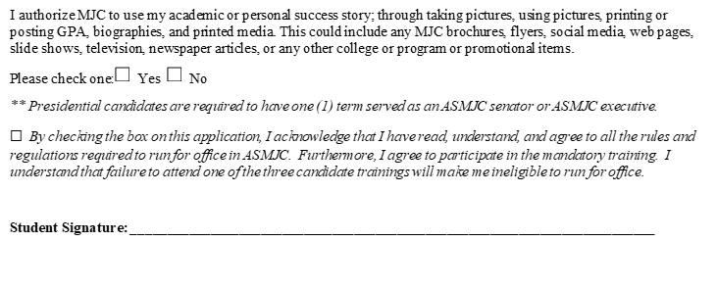
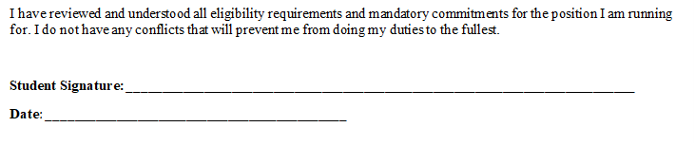
*due to COVID-19, all signatures have been waived. Please typed in your full name on signature line and send application through your student email. This will substitute your wet signature.

For more information and/or to submit your completed ASMJC Nomination Packet contact:

Alejandra Espinoza
Campus Life & Student Learning Manager
espinozaa@mjc.edu

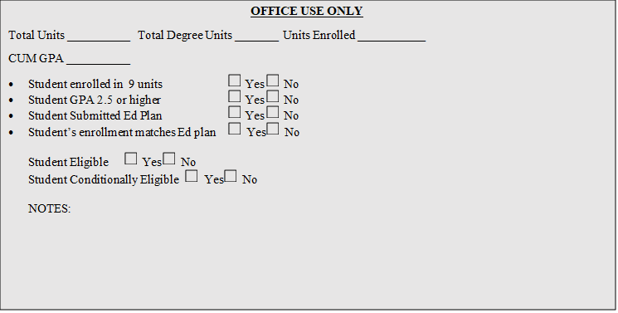
Due to COVID-19 and social distancing, the signature requirement is waived. However, all other requirements are still in effect and will be used to determine eligible and ineligible candidates. All students who submit a completed election packet by the due date and time will be notified of your candidacy status either way.

