Modesto Junior College Associated Students

Prepared by: MJC Business Services
Revised on 08/06/14 File Name: Accounting Manual-Final.docx

Cash Box Request Procedures

Cash Box Requests
- The cash box will only be released to the person listed on the Cash Box Request Form to pick-up the box.
- A contact number must be provided by the person who is picking up the cash box
- The name of the organization requesting the cash box and the type of the activity should be on the Cash Box Request Form

The security of the cash box and the volunteer entrusted with the cash box are both essential. The Cash Box Request Form should be submitted by ASMJC Office to MJC Business Services two weeks prior to the event.

Please use the following directions to complete the Cash Box Request Form (Page 10):

- Date: Enter the current date.
- Person Requesting: Enter the name of the person requesting the funds.
- Contact Number: Enter the contact number of the person requesting the funds.
- Student Government/Club: Enter the name of the Student Government or club.
- Type of Activity: Provide the type of activity that the cash box will support.
- Name of the Event: Enter the name of the event where the cash box will be used.
- Date of the Event: Provide the date of the event.
- Account Number: Enter the account number where the funds are going to be taken out of. Please make sure sufficient funds are available prior to your request.
- Number of Boxes Needed: Provide the number of cash boxes that are needed.
- Number of Lock Bags: Provide the number of lock bags that are needed.
- Date & Estimated Pick-up Time: Provide the date the box will be picked-up and the estimated time.
- Person Picking-up the Box: Provide the name of the person that will pick-up the cash box. The cash box will only be released to the person designated on the Cash Box Request Form.
- Contact Number: A contact number should be provided by the person who is picking up the cash box.
- Signatures: The Cash Box Request Form should be signed by the following individuals:
- Club Advisor(if applicable)
- ASMJC President/Designee
- ASMJC Advisor ( a designated certificated employee)
In addition:
- Cash Box Request Forms received without the authorized signatures and account numbers without sufficient funds will be returned to the ASMJC Office.
- The cash box will be available at the MJC East Campus Business Services Office for pick-up during regular business hours.
- When an event concludes and the funds are counted, the cash box and funds need to be returned to MJC Business Services immediately.
- During regular business hours, funds should be dropped off at Business Services’ Merchant Window.
- After regular business hours and during weekends and holidays, a drop box is available at MJC’s East Campus Business Services Office under the Merchant Window.
- Arrangements can be made with the Security Office to assist you on weekends and holidays.
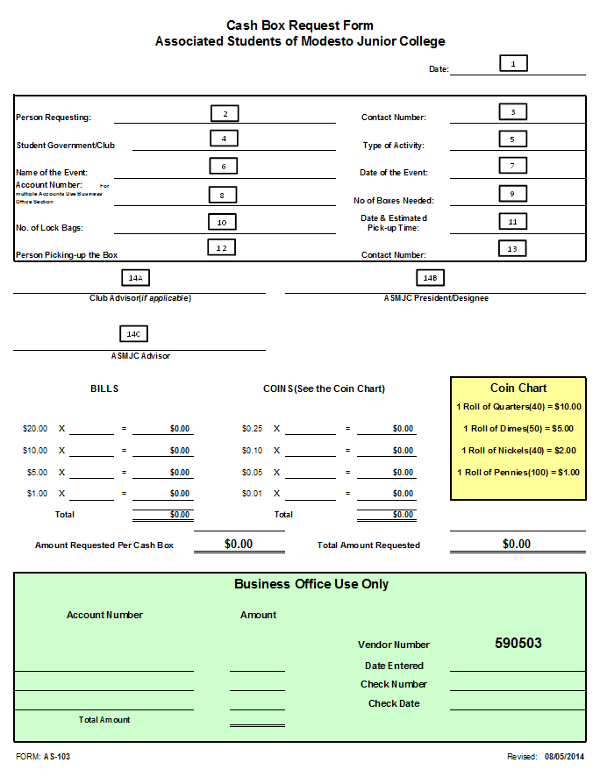
Cash Receipt Management & Procedures
Below are the cash receipt procedures:
- MJC Business Services will not accept any deposits unless they are accompanied by a signed Associated Students Deposit Form (see below).
- All deposits should be put in a sealable, pre-numbered Drop Safe Register Bag. The bags are provided at the Business Services’ Merchant Window and ASMJC Office.
- Business Services will offer a written receipt indicating the amount of cash shown on the Associated Student Deposit Form as an estimate until the deposit is verified.
- After the deposit has been received by MJC Business Services, it will be counted and verified by two MJC Business Services staff members.
- After verification, a cash receipt is created in Colleague (Datatel).
- A copy of the cash receipt will be put in the ASMJC box that is located in the MJC Business Services Office. Only authorized personnel (ASMJC Staff/Advisor) or their designees have access to that box.
- The deposit will be made to the bank account within forty-eight (48) to seventy-two (72) hours of receiving the deposit.

Associated Students Deposit Form
Please use the following directions for completing the Deposit Form (Page 12):
- Student Organization/Club Name: Every deposit must have the name of the organization on the Associated Students Deposit Form.
- Event Name: The name of the event must be included with each deposit.
- Event Date: Provide the date of the event.
- Account Number: In order to avoid delays and inaccuracies, every deposit must have an account number on the Associated Students Deposit Form.
- Bills: Enter the quantity and amount of each denomination.
- Coins: Enter the quantity and amount of each denomination.
- Total Checks: Enter the total amount of the checks received in this section (please attach a tape).
- Total Received: Enter the total of all funds received during the event in this section.
- Beginning Cash (Cash Box): Enter the amount of start-up funds you received prior to the event.
- Detailed List: The Student Organization/Club must provide a detailed list of the revenue received from the event. This will avoid over taxation. NOTICE: The total amount of the deposits without a detailed description of the revenue earned during their event will be taxed.
- Total Event Revenue: The total revenue in this section should correspond to the total cash received during the event.
- Signatures: Every Associated Students Deposit Form must be signed by two individuals as follows:
- ASMJC President (designee)/Club Officer
- ASMJC/Club Advisor
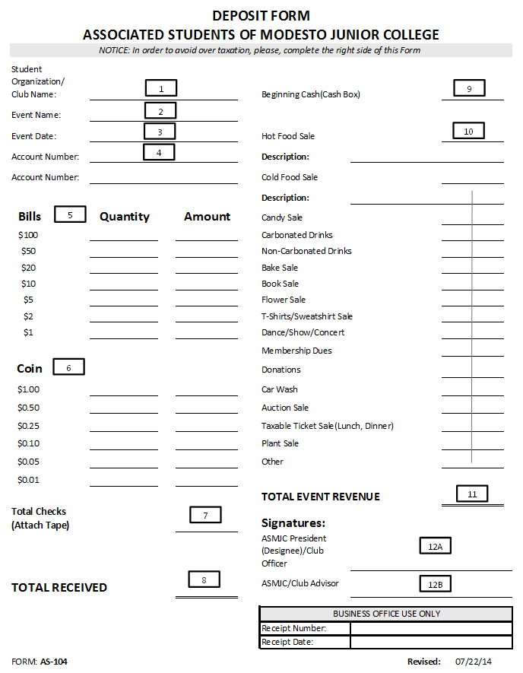
SAMPLE OF BANK OF AMERICA’S DROP SAFE REGISTER BAG

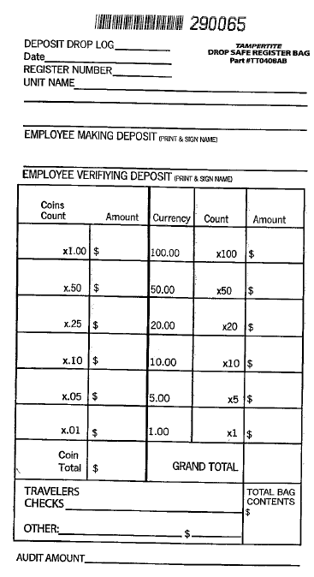
Internal Controls

In general, the internal controls over cash disbursements should ensure that:
- Students and staff members never pay for an expense out of cash collected from a fundraising event; all of the cash must remain intact for deposit.
- Business Services may pay for a purchase with ASMJC funds only after the items have been received and only if the purchase has been approved in advance by ASMJC Student Senate/club representative, the ASMJC Advisor, and the Vice President of Student Services (California Education Code 76063).
- Business Services must secure the check stock in a safe.
- Checks should never be signed in advance.
- Business Services should never make a check out to cash or issue a check lacking a payee name or amount.
- Business Services should maintain adequate records and audit trail, including original detail receipts of all expenses, per the District’s retention guidelines.
- The site administrator needs to ensure that members of the student government/ clubs, instructors and advisors understand that they cannot obligate ASMJC funds until appropriate approval has been obtained. For example, if an instructor places an order or goes shopping for materials without an appropriate approval, he/she is responsible for payment.
- If the vendor will not accept a purchase order but requires payment by check, the following documentation will be needed to process a check:
  - ASMJC Student Senate/Club minutes approving the expenditure.
  - A completed ASMJC Purchase Order Form (Page 16).
  - An invoice from the vendor.
- Business Services will verify that the student government/clubs have sufficient funds to pay for the goods before payment is made to the vendor. If the club does not have sufficient funds, Business Services will return the purchase order to the ASMJC Office with a request for a budget revision or a payment plan for the item.
- The invoice may be slightly higher or lower than the original purchase order. Business Services will not process any purchase order that exceeds the original Business Office Purchase Order by more than $50. Business Services must obtain additional approvals before the payment is made.
- Per District’s policies and procedures, the reimbursement for all staff and students are limited to $100. A cash advance must be requested for purchases over the stated limit.

