The 2022-23 Perkins/Strong Workforce Project Application is designed to capture the details of college proposals that impact Career Education programs at MJC. Merging the two applications into one will facilitate a much simpler process, requiring only one application per year.

What do we mean by Career Education and/or Career & Technical Education? Career Education (CTE) programs are defined as college certificates and degrees that respond to industry sectors by preparing students for vocational professions. CTE programs are made up of college credit or noncredit classes that have a SAM CODE as follow; a= apprenticeship, b= advance CTE, c= clearly CTE, or d= possibly CTE.

Intent behind Carl Perkins and Strong Workforce Funding.

Strong Workforce: Community colleges in California receive Strong Workforce state funding for “more” and “better” CTE. “More” refers to workplan activities that invest resources that grow student enrollment in CTE program areas and/or classes. “Better” refers to workplan activities that invest resources to increasing the achievement of 9 units in the program, certificate completions, degree completions, and/or transition to high-wage high-demand professions in the industry. Guidance on recommended strategies can be found in the 25 recommendations from the CCCCO Strong Workforce Taskforce.

Carl Perkins: Community colleges nationwide receive federal grant resources to support investments that lead to the success of “Student from Special Populations” enrolled in Career & Technical Education (CTE) programs. Success metrics are defined by evaluating course completion and success, unit persistence, program completion, and post program employment.

Perkins V aims to develop the academic knowledge and technical and employability skills of students who elect to enroll in Career & Technical Education programs/pathways by

Developing challenging academic and technical standards including the preparation for high skill, high wage, or in-demand occupations in current or emerging professions.

Promoting services and activities that integrate academic and CTE instruction and link secondary education and post-secondary education for participating CTE students.

Disseminate national research and information on best practices to improve CTE programs and programs of study, services or activities.

Promote leadership and improve the quality of CTE faculty and staff.

Support partnerships among education, business and industry, and government.

Provide individuals the opportunities throughout their life to development through education, training and knowledge, and skill acquisition.

Increase employment opportunities for “special populations” who are chronically unemployed or underemployed.

In the 2022-23 Academic Year, Perkins responses focusing on student “persistence” strategies in pursuit of CTE certificates and/or degrees will receive priority. The emphasis addresses Perkins data for MJC that identifies a gap in Core 3: persistence across most CTE program areas for “special population” students as indicated in the two charts below:

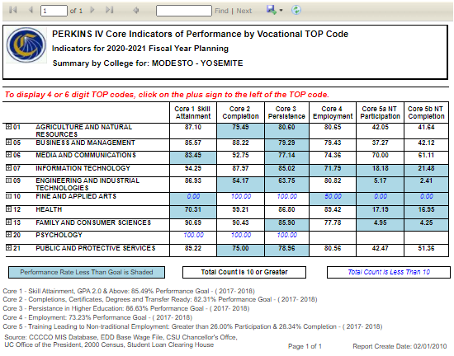

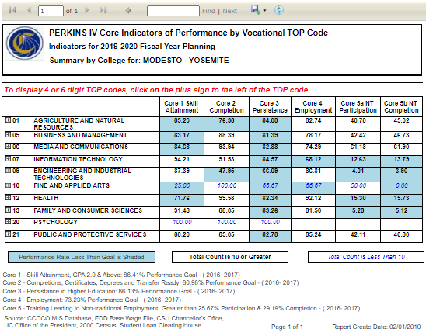

APPLICATION DETAILS

APPLICATION DUE DATE: Monday, February 14, 2022 by 12:00pm.

Email your proposed program application to Manny Walsh @ walshm@mjc.edu

Questions and Technical Assistance?

Contact Pedro Mendez @ by email mendezp@mjc.edu

APPLICATION PROCESS

Who is eligible to Apply?

CTE Instructional Program Areas

Non CTE Instructional program area departments that are clearly and explicitly collaborating with CTE Program Instructional Areas

Application Checklist: What’s needed to apply?

Complete the 2022-23 Funded Year Application: Complete attached application, sign and review with your Division Dean.

CTE Program Area Advisory Committees Attachments: Attach a list of the current program advisory membership (Name, Title, Organization, Phone and Email) and advisory committee meeting minutes from the 2021-22 academic year.

Division Dean Review and Approval: Division Dean ensures application is complete and in signing confirms their support, agreement and commitment and obligations of resources by the Division for the project. Dean submits request on behalf of the department area.

Division: | Choose an item. | Date: | Click or tap to enter a date.

Contact and Project Information
Program Area/ Department Requesting Funding:
Project Title:
Person(s) on Project Team:
Lead Person Responsible for your project from beginning to end:
Project Start Date: | Project End Date:
Brief Description:

Dean Signature: |  | Date:
If Non CTE Program Area, Partnering CTE Area:
Division Dean Name and Signature:
Facility Modernization: Is your proposal requiring classroom, lab, building or site modification?
☐ YES ☐ NO
If yes, the signature below confirms that this project has been discussed with YCCD’s Facilities Planning Department to inform the proposed project.

Director of Facilities Planning & Operations Signature: |  | Date:

Labor Market Information
What region/sub-region or county labor market needs does this program target? (Supply and demand data must be for the same geographic area). | (Example: Tuolumne County or Central Valley)
Industry Sector:
Guided Pathway School(s):
What Program Area(s) and TOP Code(s) are you proposing?

For Strong Workforce: Does 50% of your program completers meet the Living Wage threshold as reported in the LaunchBoard: Strong Workforce Metrics or LaunchBoard: Community College Pipeline?  - If YES, copy and paste the screen shot from Launch Board below:  - If NO, please provide supply and demand data and the source used to gather this information below: | ☐ YES  ☐ NO
LMI Launch Board Data and/or LMI Demand and Supply Data Information:

NEED STATEMENT:

Describe the Need for this project. Review and discuss applicable information related to your proposed project as found in the CCCCO CTE Core Indicator Website and/or CCCCO Launchboard Website .

Given your review of this information, list the student success gaps and needs that your proposal is seeking to address. Be specific: what certificate and degrees will be impacted, which classes, anticipated # of students, and if applicable, improving the access and success for “students from special populations” with respects to CTE programs or pathways.

RESPONSE: Project Work Plan
PLANNED ACTIVITIES: Describe how your plan proposes to address the “NEEDS” listed above. Discuss the faculty and/or staff, curriculum efforts, support service needs, technology and equipment, or other resources that are needed. Provide a brief outline of how the program will unfold each year.

Project Rationale: What needs motivates this project and how will the Response (project work plan) address the Need you have described? Is this request connected to the recently submitted 2021-22 Program Review for this CTE Instructional Program Area? IF so how? (2-3 paragraphs)

Proposed Project Goals: Describe the 2-3 goals. Goals are broad statements requiring 3-4 objectives to complete.
1
2
3

Workplan: Complete workplan information for either “Single Year Project” or “Two Year Project”. Link your objectives to your goals above.

For Single Year Projects: FY 2022-2023 [July 1, 2022 – June 30, 2023]
Objective:
Activity | Expected Outcome | Start Date & End Date | Person Responsible

Objective:
Activity | Expected Outcome | Start Date & End Date | Person Responsible

Objective:
Activity | Expected Outcome | Start Date & End Date | Person Responsible

Objective:
Activity | Expected Outcome | Start Date & End Date | Person Responsible

Objective:
Activity | Expected Outcome | Start Date & End Date | Person Responsible

For Two Year Projects: FY 2022 - 2024 [July 1, 2022 – June 30, 2024]
Objective:
Activity | Expected Outcome | Start Date & End Date | Person Responsible

Objective:
Activity | Expected Outcome | Start Date & End Date | Person Responsible

Objective:
Activity | Expected Outcome | Start Date & End Date | Person Responsible

Objective:
Activity | Expected Outcome | Start Date & End Date | Person Responsible

Objective:
Activity | Expected Outcome | Start Date & End Date | Person Responsible

Objective:
Activity | Expected Outcome | Start Date & End Date | Person Responsible

Objective:
Activity | Expected Outcome | Start Date & End Date | Person Responsible

Student Success Metrics: (1) Describe the college metrics you project will “improve / increase” and how specifically your project will accomplish this. Some examples of metrics include: students enrollment in selected CTE Classes, students in the program, # of students completing certificates, number of students completing 9 units in CTE classes, numbers of students transferring, # of students employed post program, etc..

Diversity, Equity and Inclusion: Please describe any strategies your project will implement to address identified DEI student and/or program needs.
Sustainability: Describe how these investments will be sustainable after project completion? Do you anticipate ongoing costs beyond the life of the project end date? Be specific in your explanation.

Project Risks: Describe the risks most likely to prevent the successful completion of this project.

BUDGET: Complete the budget worksheet below. Provide as much detail as possible.

Object Code |  | Description: Describe Activity and include Details & Specific Calculations. | Amount
1000: Instruction | 51XXX: One Year Temp FT or Permanent Request (Requires explanation of how position will be sustained beyond this project funding) | Click or tap here to enter text. | Type Amount
 | 51330: Instruction PT/OL | Click or tap here to enter text. | Type Amount
 | 51430: Non-Instruction (Stipends: Must follow new contract language on stipends) | Click or tap here to enter text. | Type Amount
2000: Classified | 52XXX: Permanent Request (Requires explanation of how position will be sustained beyond this project funding) | Click or tap here to enter text. | Type Amount
 | 52330: Non-Inst. Hourly | Click or tap here to enter text. | Type Amount
 | 52331: Student Worker | Click or tap here to enter text. | Type Amount
 | 52431: Instr. Aide Hourly | Click or tap here to enter text. | Type Amount
3000: | 53000: Benefits & Fringes (Permanent position request at 55-65% of amount) | Click or tap here to enter text. | Type Amount
3000: | 53000: Benefits & Fringes (PT/OL hourly positions at 12% of amount) | Click or tap here to enter text. | Type Amount
4000: Supplies | 54301: Instructional Supplies | Click or tap here to enter text. | Type Amount
 | 54431: Non-Inst. Supplies | Click or tap here to enter text. | Type Amount
5000: Services | 55101: Local Travel | Click or tap here to enter text. | Type Amount
 | 55102: Out of District Travel | Click or tap here to enter text. | Type Amount
 | 55104: Field Trip | Click or tap here to enter text. | Type Amount
 | 55211: Fees | Click or tap here to enter text. | Type Amount
 | 55436/55443: Contracted Service | Click or tap here to enter text. | Type Amount
 | 55440: Outreach | Click or tap here to enter text. | Type Amount
 | 55668: Prof. Development | Click or tap here to enter text. | Type Amount
6000: Equipment | 56311: Lib. Print Books | Click or tap here to enter text. | Type Amount
 | 56312: Lib. Elec. Books | Click or tap here to enter text. | Type Amount
 | 56322: Lib. Elec. Subscription | Click or tap here to enter text. | Type Amount
 | 56270: Modernization (Facilities) | Click or tap here to enter text. | Type Amount
 | 56400: Under $5K | Click or tap here to enter text. | Type Amount
 | 56450: Over $5K | Click or tap here to enter text. | Type Amount
 |  | TOTAL | $ Type Amount

