The MJC Perkins/Strong Workforce Project Application is designed to capture the details of college proposals that impact Career Education programs at MJC. Merging the two applications into one will facilitate a much simpler process, requiring only one application per year.

What do we mean by Career Education and/or Career & Technical Education? Career Education (CTE) programs are defined as college certificates and degrees that respond to industry sectors by preparing students for vocational professions. CTE programs are made up of college credit or noncredit classes that have a SAM CODE as follow; a= apprenticeship, b= advance CTE, c= clearly CTE, or d= possibly CTE.

Intent behind Carl Perkins and Strong Workforce Funding.

Strong Workforce: Community colleges in California receive Strong Workforce state funding for “more” and “better” CTE. “More” refers to workplan activities that invest resources that grow student enrollment in CTE program areas and/or classes. “Better” refers to workplan activities that invest resources to increasing the achievement of 9 units in the program, certificate completions, degree completions, and/or transition to high-wage high-demand professions in the industry. Guidance on recommended strategies can be found in the 25 recommendations from the CCCCO Strong Workforce Taskforce.

Carl Perkins: Community colleges nationwide receive federal grant resources to support investments that lead to the success of “Student from Special Populations” enrolled in Career & Technical Education (CTE) programs. Success metrics are defined by evaluating course completion and success, unit persistence, program completion, and post program employment.

Perkins V aims to develop the academic knowledge and technical and employability skills of students who elect to enroll in Career & Technical Education programs/pathways by

Developing challenging academic and technical standards including the preparation for high skill, high wage, or in-demand occupations in current or emerging professions.

Promoting services and activities that integrate academic and CTE instruction and link secondary education and post-secondary education for participating CTE students.

Disseminate national research and information on best practices to improve CTE programs and programs of study, services or activities.

Promoting leadership and/or improving the quality of CTE faculty and staff.

Support partnerships among education, business and industry, and government.

Provide individuals the opportunities throughout their life to development through education, training and knowledge, and skill acquisition.

Increase employment opportunities for “special populations” who are chronically unemployed or underemployed.

In the 2024-25 Academic Year Application, Perkins & Strong Workforce proposals focusing on one or more of the following areas will receive priority:

Apprenticeship Projects: Development or growth of apprenticeship programs.

Community Projects: Opportunities for students to become involve in work base or service learning projects in our local community.

Dual Enrollment: Intentionally Designed Dual Enrollment between CTE High School Programs of Studies to MJC CTE Program certificates and/or degrees.

Non-Credit CTE Certificates: Development of CTE discipline noncredit certificates (CDCP)

“Equity” Persistence & Completion Projects: The emphasis addresses Perkins data for MJC that identifies a gap in Core 3: persistence and completion across most CTE program areas for “special population” students as indicated in the two charts below:

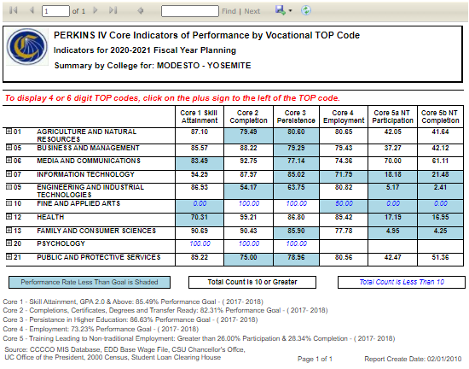

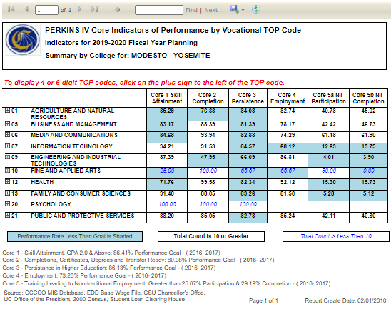

APPLICATION DETAILS

APPLICATION DUE DATE: EXTENDED to: Monday, December 20, 2023 by 12:00pm.

Email your proposed program application to Rebecca Heinrich by email heinrichr@yosemite.edu

Questions and Technical Assistance? Contact Saul Guzman by email guzmans@yosemite.edu

APPLICATION PROCESS

Who is eligible to Apply?

CTE Instructional Program Areas

Non CTE Instructional program area departments that are clearly and explicitly collaborating with CTE Program Instructional Areas

Application Checklist: What’s needed to apply?

Complete the Application: Prepare accurate and fully completed application.

CTE Program Area Advisory Committees Attachments: Attach a list of the current program advisory membership (Name, Title, Organization, Phone and Email) and advisory committee meeting minutes from the prior academic year.

Division Dean Review and Approval: Division Dean reviews application and signs to confirm support, agreement and commitment and obligations of resources by the program area. Dean submits final application on behalf of the author(s) and program area.

