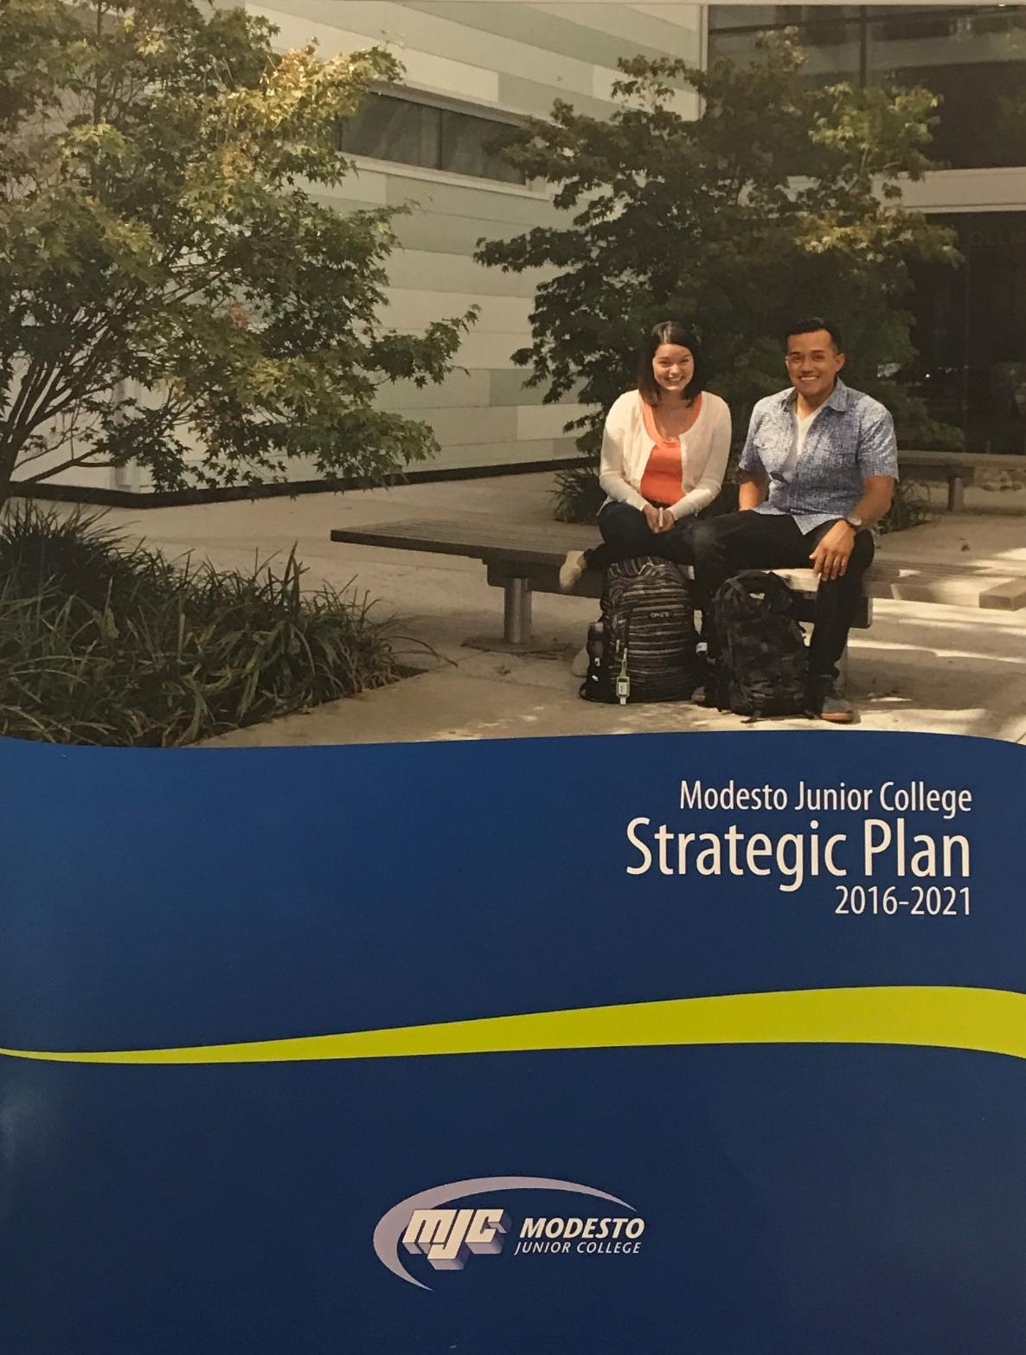
June 2017
Student Services
Program Review

Modesto Junior College

Student Services Program Review
June 2017
Contents
Program Mission and Accomplishments 2
Student Achievement and Completion 3
College Goal for Student Achievement 3
Success 3
Student Learning Outcomes 4
Student Learning and Outcomes Assessment 4
Additional Support Services Area Program Data 6
Additional Program Data 6
Program Analysis 7
Program Personnel 7
Long Term Planning and Resource Needs 8
Resource Request and Action Plan 8
Evaluation of Previous Resource Allocations 8
Appendix 9
Optional Questions 9
Review Process Feedback 9
Executive Summary 10

Program Mission and Accomplishments
MJC is committed to transforming lives through programs and services informed by the latest scholarship of teaching and learning. We provide a dynamic, innovative, undergraduate educational environment for the ever-changing populations and workforce needs of our regional community. We facilitate lifelong learning through the development of intellect, creativity, character, and abilities that shape students into thoughtful, culturally aware, engaged citizens.
Provide a brief overview of the program and how it contributes to accomplishing the Mission of Modesto Junior College. (Overview Suggestions: How consistent is the program with the institutional mission, vision, core values and/or goals? How are aspects of the institutional mission addressed within the program? Is the program critical to the pursuit of the institutional mission?)

Briefly describe the activities and accomplishments of the department since the last program review.

On the Departmental Program Review webpage, please locate your department and the previous program review. After viewing the commendations and recommendations, please complete the following questions;
Describe how your department has responded to the commendations and recommendations of the previous review.

Student Achievement and Completion

College Goal for Student Achievement
Increase Scorecard Completion Rate for Degree and Transfer
The College has a primary aspirational goal of increasing the Completion rate from 43% to 53% on the CCCCO Scorecard Completion Rate for Degree and Transfer [view] by 2022. The completion rates in the Scorecard refers to the percentage of degree, certificate and/or transfer-seeking students tracked for six years who completed a degree, certificate, or transfer-related outcomes (60 transfer units).
As you answer the questions below, please consider how your program is helping the college complete this aspirational goal of increasing the MJC Degree, Certificate, and Transfer Completion rate by 10% on the CCCCO Scorecard by 2022.

Success
The following questions refer to data from the Success Rate Data Dashboard or data regarding student achievement from the Office of Institutional Effectiveness. If using the data dashboard, use the filters to examine both departmental and course level data. Charts will be included for the record by Research and Planning once the review is submitted.
First, define the achievement data you are using for program review. What groups are you measuring? What indicators are you measuring? For how long (two-year trends are recommended)? Is there a comparison group—for example, against the college average or students who do not participate in your activity?

Consider your data. Are these rates what you expected? Are there any large gaps? Is there anything surprising about the data? What do you see in the data? Write a brief analysis.

Given the data, what is your set goal for success? Do your department and individual course rates meet this goal? If your rates for success are lower than your goals, what are your plans to improve them?

Consider your department equity rates on the Success Rate Data Dashboard (by pressing on the equity tab) or through the data provided by the Office of Institutional Effectiveness. Examine your disaggregated data over the last two years. Consider any student equity gaps—the differences across student populations, especially in relation to the highest performing group. How do you plan on addressing issues of equity in your area? In other words, how do you plan on closing achievement gaps across student populations?

Student Learning Outcomes
Instructions
This section of the Program Review measures support services learning outcomes, service area outcomes, and institutional learning.
SSLO / SAO/ ILO Outcomes
To ease in analysis, trending charts have been created by Research and Planning on the Learning Outcomes Dashboard website or through a specific data set prepared for your area. Using these charts, you can identify your current rates in student learning outcomes. You will consider your outcomes, set a department goal, examine your SLO data, and outline a plan for any needed improvement.
Note for those using the Learning Outcomes Dashboard website: If the dashboards do not show your Learning Outcomes, please ensure that they have been mapped in eLumen. Each SSLO will need to be mapped to each applicable SAO and ILO. The Outcome Assessment Workgroup has created a web page detailing the work already done -> PLO, ILO, and GELO Assessment grids. For additional assistance, review the Course Learning Outcome Assessment web pages, or contact Nita Gopal at gopaln@mjc.edu.

Student Learning and Outcomes Assessment
Please review your Student Learning Outcomes data located on the MJC Student Learning Outcomes Assessment website or through the specific data set prepared for your area.
For each SAO that your SSLOs inform, you will find your overall rate. You will also see that overall rate disaggregated across student populations; you can use this information to understand how different student populations are learning in your support services areas.
After you have examined your rates and disaggregated data, reflect on the data you encountered. Please address the service area outcomes (SAOs), and institutional outcomes (ILOs) in your analysis.
Service Area Outcomes (SAO)
What is your set goal for SAO success? Do your overall rates meet this goal?

Institutional Learning Outcomes (ILO)
What is your set goal for ILO success? Do your overall rates meet this goal?

Continuous Quality Improvement
If your rates for success for any SAOs or ILOs are lower than your goals, what are your plans to improve them?

Equity and Success
Do your rates for your SAOs and ILOs vary across student populations? How you do you plan on addressing issues of equity? In other words, how do you plan on closing the learning gaps across student populations?

Additional Support Services Area Program Data

Additional Program Data
You may be asked to include additional data—or want to include additional data—regarding your service area. Please include your data below or attach it to your program review, set a goal regarding your data that would indicate success, and develop a plan for any improvements.
Additional Program Data
Please include your data in the box below or via an attachment. Write a brief description of the data, why it is important, and what it shows about your program. If you have different data sets, please identify and write about them separately.

Analysis
Given the data you have provided, provide a set goal for success regarding the data, review your data, and provide a plan for improvement if needed. Also examine whether or not your data and rates vary across student populations. Discuss how you plan to address issues of success and equity.

Program Analysis

Program Personnel
Please refer to the Department Faculty and Sections Dashboard to supply the names of faculty and adjuncts for the periods requested, and also supply the names of classified profsssionals and administrators in your area. Additional comments or narrative can be added below.
Faculty Name | Position Title: Full-Time or Part-Time | Hire Date (optional)

Classified Professional Name | Position Title: Full-Time or Part-Time | Hire Date (optional)

Administrator Name | Position Title: Full-Time or Part-Time | Hire Date (optional)

Additional Notes regarding personnel

Long Term Planning and Resource Needs
Provide any additional information that hasn't been addressed elsewhere in this program review, such as environmental scans for opportunities or threats to your program, or an analysis of important subgroups of the college population you serve.
View the Program Review Instructions page for reference and inspiration.
Taking into account the trends within this program and the college, describe what you realistically believe your program will look like in three to five years, including such things as staffing, facilities, enrollments, breadth and locations of offerings, etc.

Resource Request and Action Plan
The link below will launch the Launch SLO Resource Allocation Request portion of the review. This will open in a new window, allowing you to input your program requests in regards to improving student learning outcomes. Overall program needs can be added at the end of the review.
Please number the beginning of each line on your resource request with the priority ranking, 1 most important, 2 next, etc.
When complete, please return here and continue with your final entries.
Priority | Name | Resource Type | Estimated Cost | Objective

Evaluation of Previous Resource Allocations
Below is a list of resource allocations received in previous Program Reviews. Please evaluate the effectiveness of the resources utilized for your program. How did these resources help student success and completion? (https://www.mjc.edu/governance/rac/documents/ielmallocationsummary20142015.pdf)
The Evaluation / Measured Effectiveness can be typed in another program and pasted here, or typed directly in to the box below. The box will expand with additional text, and paragraphs (hard returns) can be added by using Ctrl+Enter.
Resource Allocated | PR Year | Evaluation / Measured Effectiveness

Appendix

Optional Questions
Please consider providing answers to the following questions. While these are optional, they provide crucial information about your equity efforts, training, classified professional support, and recruitment.
What strategies do you use to recruit, support and retain students from disproportionately impacted groups?

Does your division (or program) provide any training/mentoring for faculty to support the success of students at risk of academic failure?

Is there a need for more classified professional support in your area, please describe this need. Indicate how it would support the college mission and college goals for success, and completion.

What factors serve as barriers to recruiting active faculty to your program(s)?

Review Process Feedback
Please share any recommendations for improvements in the Program Review process, analysis, and questions. Your comments will become part of the permanent review record.

Executive Summary
Provide an executive summary of the findings of this program review. Your audience will be your Division Program Review Group, the MJC Program Review Workgroup, and the various councils of MJC.

