Executive Summary
Our review of all Auto Body Collision, Repair and Refinishing Programs began with a review meeting on April 26, 2013. During this meeting members reviewed various documents including: Program Mapping, Student Learning Outcome Course Evaluation Summary Forms, Outcome Assessment Reports, Advisory Minutes and EMSI Data. The written responses were then circulated amongst members for additional comments, questions, additions and edits in arriving at the final “reflection” found in this document.

PROGRAM MAP
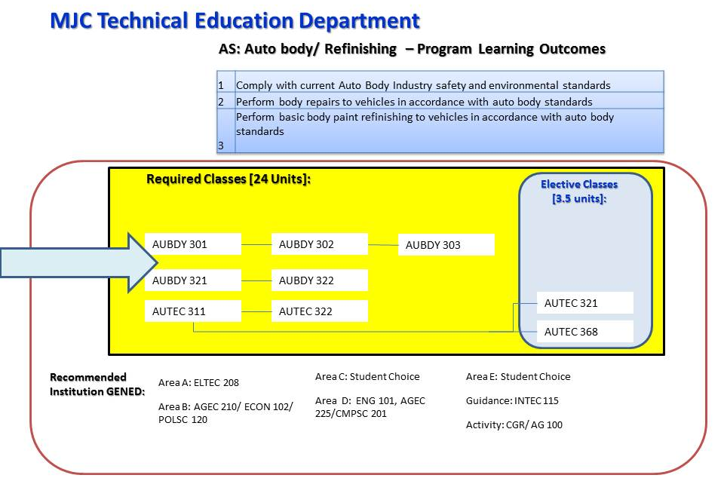

CLO to PLO MATRIX:
PLOs:
Upon satisfactory completion of the course requirements for the Autobody/Refinishing Associate of Science Degree the student will be able to:
COURSE ID | CLO#: Students succesfully completing this course will be able to: | 1. Demonstrate compliance with current autobody industry safety and environmental standards. | 2. Work successfully in the autobody/collision repair industry. | 3. Perform body repairs in accordance with autobody industry standards.
AUTEC 311 | 1. Demonstrate a basic understanding of basic workshop safety. | D | I
AUTEC 311 | 2. Demonstrate a basic understanding of the operating characteristics of major automotive systems. |  | D
AUBDY 301 | 1. Demonstrate the ability to comply with Industry safety and environmental concerns. | I,D | I
AUBDY 301 | 2. Diagnose and perform minor repairs on non-structural automotive steel panels. |  | I | I
AUBDY 302 | 1. Demonstrate knowledge and utilize various metal inert gas welding methods used in repair or replacement of steel automotive panels. | D | D | D
AUBDY 302 | 2. Diagnose and perform minor repairs on various automotive composite and plastic panels. |  | D | D
AUBDY 303 | 1. Identify major components of a typical passenger compartment and diagnose proper repair or replacement procedures. |  | D | D
AUBDY 303 | 2. Identify, diagnose and perform repair or replacement procedures related to substrates, sections structural components and assemblies used in vehicle construction. | D | D | D
AUBDY 321 | 1. List and explain the steps involved in the application of paint to a vehicle and demonstrate these techniques on a vehicle fender. | I,D | I | I
AUBDY 322 | 1. Write an estimate on a full vehicle project that will lead to a complete paint job. |  | D | D
AUBDY 323 | NO CLOS! THIS COURSE NEEDS CLOS! | REVIEW: THIS IS AN ERROR | REVIEW: THIS IS AN ERROR | REVIEW: THIS IS AN ERROR
AUTEC 321 | 1. Demonstrate an understanding of the construction and operation of automotive braking systems. | I,D | D | D
AUTEC 321 | 2. Demonstrate understanding of diagnostic procedures for automotive braking systems. |  | D | D
AUTEC 368 | 1. Demonstrate understanding of the construction and operation of automotive starting and charging systems. | I,D | D | D
AUTEC 368 | 2. Demonstrate understanding of diagnostic procedures for automotive starting and charging systems. |  | D | D
AUTEC 322 | 1. Demonstrate understanding of the construction and operations of automotive steering and suspension systems. | I,D | D | D
AUTEC 322 | 2. demonstrate understanding of diagnostic  procedures for automotive steering and suspension  systems |  | D | D
I = Introduction, D = Development, M = Mastery

ANALYSIS
Our data analysis of the AS Degree: Auto Body / Refinishing found that students in the program are generally very successful in demonstrating that they understand the safety and environmental regulatory aspects goals of the program. Professor Beebe uses an I-CAR industry standard Safety and Pollution Prevention exam to evaluate this knowledge of students when the move through AUBDY 301 and AUBDY 321. Performance for the sample of courses evaluated show 100% of the students that took the exam passed this assessment. To examine arrival points of CLOs that link to PLO #2 on the performance of “auto body repairs,” Professor Beebe relies on 3 additional exams for assessments the I-CAR Plastic Repair Program Post Exam, the ASE Paint & Refinishing (B2) industry prep exam, and the ASE non-structural analysis and damage (B3) industry prep exam. Students performed very well in these exams confirming the understanding of knowledge on how to perform Auto Body Repairs. However, the CLO assessment tool structure has failed to collect data on the actual work performed by students. Finally, our review found that AUBDY 321 and 322 CLO statements were not comprehensive and need to be expanded to ideally have 2-3 CLOs per course.
For the Automotive Technology skills and knowledge expectations assessment information was less structure and more difficult to determine the body of knowledge being understood by students as well as an evaluation of their performance. AUTEC 322: Steering and Suspension Systems, for example, looked to its final exam as an assessment tool. The information provided was vague and only examined 1 CLO for the course during the assessment period. A similar approach was used in AUTEC 321 and really did not inform knowledge gained or performance from Course Evaluation Summary. AUTEC 311 and 368 provided more specific information over students meeting CLO safety related outcome goals and diagnostic procedures for automotive starting and charging systems. The relation of this information to Program Learning Outcomes is not as clearly linkable.
PROGRAM CHANGES MADE IN FY2012-13
In Summer of 2012, MJC held a college wide event on outcome assessment. The review efforts from this planning day recommended programmatic removal of AUBDY 115 from the AS Degree: Auto Body Collision/ Refinishing.
ACTION PLAN
Based on this programmatic PLO and CLO evaluation the following action items have been identified.
- AUBDY 321 and AUBDY 322 need to have 2-3 CLOs per course to fully capture the purpose of the course
- Laboratory Assessments need to be developed and linked to the CLOs that support PLO 2 or specifically evaluate for PLO 2. It is anticipated that these assessment can be achieved via comprehensive project assessments in AUBDY 322 and AUBDY 303 which are end points to refinishing and body repair program, respectively.
- AUTEC CLOs need to have a clearer link to the PLOs for the AS Degree Auto Body Collision/ Refinishing Program
- All AUTEC CLOs need to be completely assessed. This did not happen during the initial period.
- AUTEC CLO assessment tools need to be more clearly described for both knowledge gain assessment and practicum assessments.

Faculty Included in the Preparation and Sharing of this Report:
Jeff Beebe, Auto Body Collision & Repair
Elizabeth Hondoy, Workforce Skills (Adjunct)
Gerald Wray, Automotive Technology

Please provide a brief and cogent narrative in response to each of the following questions.
- Are the course learning outcomes (CLOs) on your spreadsheet accurate (as of right now), and do they represent the overall purpose(s) of the course(s)? Please explain why or why not.
No. The AUBDY 323 course does not exist and AUTEC 322 was missing from the matrix. These have been corrected in the matrix. The course learning outcomes statements (CLOs), with the updates, on the current spreadsheet are accurate and are a proper representation of the “outcome” expectations for students for each course.

- Are the program learning outcomes (PLOs) on your spreadsheet accurate (as of right now), and do they represent the overall purpose(s) of the program? Please explain why or why not.
1. Yes the program learning outcomes are accurate.
2. Somewhat. The program learning outcomes could be improved to capture the automotive system knowledge and skills being expected of students by the program. Career Technical Education programs must emphasize “being able to do” quality and timely work to enter the professions. Because this is an AS Degree program academic foundational education is added to the expectations of students. How does a program assess for over-arching student learning outcome difference of degree pursuing students and certificate or skill recognition students?
This concept of PERFORMANCE is at the heart of all CTE Programs. PLO #2 and #3 speaks in broad terms to the ability to perform basic repairs in accordance to industry standards. In the Auto Body Industry those standards are driven and measured via points and/or certification by I-CAR and ASE. To this end, the assessment tests used confirms understanding of content knowledge, and specific course lab work assesses arrive point of the student’s ability to performance. It does not however, provide evidence that the student is actually able to do the work (this point will be discussed in later questions). Nor does the program have any collection element with respect to general education courses being completed by students or an assessment target to evaluate this level of academic rigor and expectation.
- How well do the course learning outcomes (CLOs) fulfill, support and align with the program learning outcomes (PLOs)? Additionally, just in terms of the structure, do you think the assessment data from the CLOs can tell a qualitative and quantitative story about the PLOs? Please explain, and take some time to think through and write about what kinds of PLO analysis your CLO assessments will foster.

The CLOs align do align to the 3 written PLOs. How well is unclear. The I-CAR SP2 Collision Safety & Pollution Prevention Pollution Test provides the instructor with assessment data this is directly used and linked to industry standards. This assessment is a good gauge of student understanding of safety and environmental regulatory information. The ASE Practice (B2): Painting and Refinishing Assessment, the ASE Practice (B3) Non-Structural Analysis and Damage Repair Assessment and the ICAR Plastic Repair Program Post Assessment collectively provide students and the professor with a common assessment tool that aligns to I-CAR & ASE industry certification standards for students entering the Auto Body field. The information from our review confirms that students success in these assessment are understanding the needed material presented in lecture and reviewed in reading assignments.
Structurally, AUBDY 321 and 322 have too few CLOs to provide sufficient information for the proper assessment of program PLOs and there are no CLO or PLO documented assessment on the actual performance by students during labs.
Automotive Technology course assessment summary reports do not provide sufficient substance to evaluate how well student are gaining knowledge or performing. As we get more involved in CLO assessment we realize that the initial methods utilized may need revision. Certainly all CTE programs should assess practical ability and the most appropriate method is with the use of task sheets in the lab environment. Sometimes however, the scope of the task sheet can be a problem, as they need to be specific enough for a particular task, (as specified by NATEF, I-Car etc.), and also be all encompassing to provide sufficient evidence for a CLO. Possibly a summative practical assessment, incorporating the more specific tasks, would be more appropriate in measuring the skills of our completers.

- You’ve mapped your CLOs to PLOs. You’ve also been provided CLO assessment data in your packet. Now, take some time to reflect on, consider and analyze the data you have. This is not an easy section to complete, and the purpose of this pilot is to generate thoughtful reflection on—and assessment of—PLOs in relationship to our CLO assessment data.

Please look at every CLO data sheet included. Then, analyze, engage and write as much as you can, addressing the following question: what does your CLO data tell you about each of your PLOs? Be detailed, descriptive and analytical.

As you consider this question…
  - Discuss what kinds of trends you see in the data provided, and provide a qualitative assessment of each PLO.
  - Try to fill in the CLO data from each sheet on your spreadsheet, and attempt to come up with an aggregate percentage for your PLOs. Is it possible to give a PLO quantitative assessment based on all of the courses listed? Or, can you give a PLO quantitative assessment based only on your discipline/department courses?
  - Please be thorough and provide as much reflection and analysis as possible. The more analysis, the better. Feel free to write beyond this page.

Following the last evaluation review in Summer 2012, at the college wide event, faculty have updated the program to remove AUBDY 115. The new AS Degree program units remained the same due to AUTEC 311 course increasing its unit value from 3 to 4 units. The official changes take effect Summer 2013. Future assessments and reflection will inform the impact and value of this decision.
Reflection on trends the data has provided is as follows:
(a) PLO 1 regarding safety and environmental regulatory concern are being consistently met based on assessment information from AUBDY 301 and 321. Both courses use the same assessment tool to evaluate student knowledge in the subject.
(b) PLO 2 is more difficult to assess. More discussion and reflection is needed to fully vet the intent of this program learning outcome. How can readiness for industry be measured?
(c) PLO 3 is evaluated using three industry aligned paper exams. The results confirm that students understand how to perform basic repair and refinishing techniques.
Aggregated Data for PLOs – (a) PLO 1: Yes, based on assessment data collected 100% of students tested passed exam on safety and regulatory standards; (b) PLO 3: Yes an average of 91% of students demonstrated knowledge of how to implement auto body repairs to industry standard. CLO information evaluates student knowledge of how to perform basic repair and refinishing techniques. CLO assessment tools do not evaluate student application of techniques to industry standard. This would be found in quality of work expected from laboratory environments; (c) PLO 2: No. How do you evaluate ability to successful work in the auto body industry if you are not tracking placement and retention data information?

- Action Plan. Based on the assessments and analysis you have provided in questions 1-4, please consider what changes or improvements you would like to make, which might include updating your CLO or PLO statements, modifying course outlines, rethinking instruction efforts, using different assessment instruments, etc. Based on the analysis you have provided in questions 1-4, provide an action plan for improvement that draws on your assessment results and efforts.

ACTION 1: Identify and/or develop CLO assessment tools that evaluate student performance in addition to knowledge of for CLOs linked to PLO 3. It is anticipated that this will be found in the activities students perform in the lab.
ACTION 2: Ensure that AUBDY 321 and 322 have 2-3 student learning outcomes written. Presently, each course has only one CLO per course. The single CLO is not sufficient.
ACTION 3: Evaluate if PLO 2 goes is sufficient as a measureable
ACTION 4: Evaluate a clearly matrix link between AUTEC course CLOs and the AS Degree Auto Body Refinishing program PLOs
ACTION 5: Schedule a meeting with Automotive Faculty to re-examine how well assessment tools are evaluating student knowledge gains and performance in automotive systems and skills.

- The college should be making improvements based on student learning outcomes assessment, and we need to continue to document and share the improvements and progress you have already made. This is extremely important.
  - Did you make any changes in your CLO or PLO statements during the last 4-year cycle that ended in 2012, or any changes this year? Please explain what you accomplished.
  - Did you make any improvements in the areas of teaching and instruction processes, your courses, or your program? Please explain and provide details about your efforts!

No changes have been made to the CLOs for the courses involved since the original statements were authored.

AS Degree: Auto Body/ Refinishing programmatic changes were submitted and approved via the Curriculum Committee at MJC in the Fall 2012. These curricular changes followed the August 2012 college-wide assessment review process.
Because of the various online testing tools being used that are aligned with I-CAR and ASE, the professor switched the lecture room the courses to a classroom with computers (Sierra 114). This classroom change has enhanced the learning experience for students. AUTEC 368 classes also have procured and adopted electrical classroom trainers for students to use in learning electrical circuit operation and fault diagnosis.
- Please reflect on the process of learning outcomes assessment in your division and at Modesto Junior College. What do you think would make it more meaningful? How could it be improved? What would help you?

- Sharing of teaching strategies being used to improve student success or learning.
- Featuring a story each month on how specific instructors on campus are working to gather reflective information, implementing new teaching strategies, making environment changes to benefit student learning outcomes and program learning outcomes.

