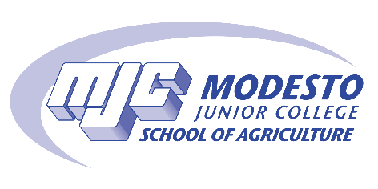

APPLICATION FOR
YOUNG FARMERS CLUB SCHOLARSHIP

APPLICATIONS SHOULD BE SUBMITTED TO
marchyl@yosemite.edu

Friday, April 8, 2022, by 5 p.m.
Awards are made on a competitive basis, consideration being given to activity involvement (Young Farmers and Agriculture Department activities), scholastic achievement, character, promise and financial need. The intent of Modesto Junior College Young Farmers in giving these funds is to make it possible for students of ability and sincere purpose to secure a college agricultural education.

PLEASE TYPE
NAME:
ADDRESS:
CITY: |  |  |  |  |  |  |  |  | STATE: |  |  |  | ZIP CODE:
TELEPHONE: |  |  |  | HOME: |  |  |  |  |  |  |  | CELL:
COLLEGE MAJOR: |  |  |  |  |  |  |  |  |  |  |  |  | CUM GPA:
UNITS COMPLETED |  |  |  |  |  |  |  |  |  |  | STUDENT W #

DO YOU PLAN TO CONTINUE YOUR EDUCATION AFTER MJC? YES NO

IF SO, WHAT COLLEGE OR UNIVERSITY?
__________________________________

YOUNG FARMER/AGRICULTURE/MJC ACTIVITIES:
PLEASE LIST CLUBS, OFFICES, COMMITTEES, ETC. THAT YOU HAVE BEEN INVOLVED.

ACTIVITIES:
LIST ACTIVITIES THAT YOU PARTICIPATED IN AND/OR WORK EXPERENCE

EDUCATIONAL AND CAREER GOALS:
PLEASE EXPLAIN YOUR EDUCATIONAL GOALS AND PLANS FOR ACHIEVING THEM.

CHECK LIST:
Yes No

• Application is typed and completed.

• A completed MJC STARS Scholarship Application must be on file.

• Application is complete & submitted by Fri., 04/8/22 by 5 pm

• An unofficial copy of your transcripts (from pirates.net)

***NO LATE APPLICATIONS WILL BE ACCEPTED.***

REMINDER – SEND APPLICATION TO:

marchyl@yosemite.edu

