Administrative Program Review
June 2017

Administrative Program Review
August 2017
Contents
Administrative Area Overview 3
The Mission of Modesto Junior College 3
Program Overview 3
Student Achievement and Completion 4
College Goal for Student Achievement 4
Success 4
College Profile 9
Remedial / ESL 9
Transfer Level Achievement 10
Completion 11
Student Learning and Outcomes Assessment 12
Administrative Unit Outcomes (AUO) 12
Institutional Learning Outcomes (ILO) 12
Analysis, Planning and Continuous Quality Improvement: AUOs and ILOs 12
Program Analysis 13
Program Personnel 13
Division Productivity Measurements 13
Long Term Planning and Resource Needs 14
Long Term Planning 14
Resource Request and Action Plan 14
Evaluation of Previous Resource Allocations 14
Career Technical Education Questions 15
How many students did you serve in the last two academic years? 15
What kinds of students are you serving? 15
What percentage of your students are persisting? Consider within the program and within the college. 15
Are students getting and keeping jobs? 15
What percentage of students are attaining a living wage? 15
Developmental Education 16
Achievement Rate for time to complete transfer level 16
Appendix 17
Optional Questions 17
Review Process Feedback 17
Executive Summary 18

Administrative Area Overview

The Mission of Modesto Junior College
MJC is committed to transforming lives through programs and services informed by the latest scholarship of teaching and learning. We provide a dynamic, innovative, undergraduate educational environment for the ever-changing populations and workforce needs of our regional community. We facilitate lifelong learning through the development of intellect, creativity, character, and abilities that shape students into thoughtful, culturally aware, engaged citizens.

Provide a brief overview of the administrative area and how it contributes to accomplishing the Mission of Modesto Junior College. (Overview Suggestions: How consistent is the administrative area with the institutional mission, vision, core values and/or goals? How are aspects of the institutional mission addressed within the administrative area? Is the administrative area critical to the pursuit of the institutional mission?)

Program Overview
Please list program awards that are under this department according to the college catalog. Next to each program award listed;
- Please denote if it should be included here, or should be listed elsewhere.
- Answer yes or no, if the program has external regulations
- Additional lines, if needed, may be added by typing the tab key while in the last cell
- Any additional notes can be added in the box below the table
[addl help]

{List degrees, certificates, and awards here}

Student Achievement and Completion

College Goal for Student Achievement
Increase Scorecard Completion Rate for Degree and Transfer
The College has a primary aspirational goal of increasing the Completion rate from 43% to 53% on the CCCCO Scorecard Completion Rate for Degree and Transfer [view] by 2022. The completion rates in the Scorecard refers to the percentage of degree, certificate and/or transfer-seeking students tracked for six years who completed a degree, certificate, or transfer-related outcomes (60 transfer units).
As you answer the questions below, please consider how your administrative area is helping the college complete this aspirational goal of increasing the MJC Degree, Certificate, and Transfer Completion rate by 10% on the CCCCO Scorecard by 2022.

Success
The following questions refer to data from the Success Rate Data Dashboard, the CCCCO scorecard, and the Program Awards Dashboard.
Use the filters in the Success Rate Dashboard to examine departmental course level and degree attainment data in your area over the last two years. In the equity tab, examine disaggregated success rates by ethnicity, modality and gender. Finally, examine degree and certificate attainment rates at the college and department level on the program awards dashboard.
Use the CCCCO Scorecard to examine disaggregated Math and English/ESL Metrics, Completion Metrics, and CTE Metrics.
Review the Program Awards Dashboard, using the drop-down filters to focus the analysis on your division.

After examining the above data, are these rates what you expected? Are there any large gaps? Is there anything surprising about the data? What do you see in the data?

If distance education is offered, consider any gaps between distance education and face-to-face courses. Do these rates differ? If so, how do you plan on closing the achievement gaps between distance education and face-to-face courses?

If there are differences in success across groups, how will your administrative area help to close achievement gaps across student populations, and how will it contribute to overall success? In other words, how do you plan on closing achievement gaps across student populations and raise completion/degree rates? How will your area help to increase the CCCCO Scorecard Completion rate to 53%?

College Profile
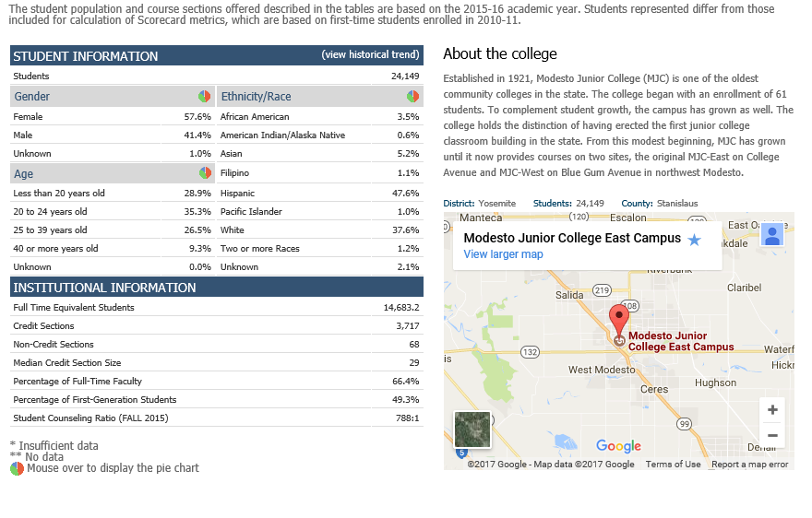

Completion
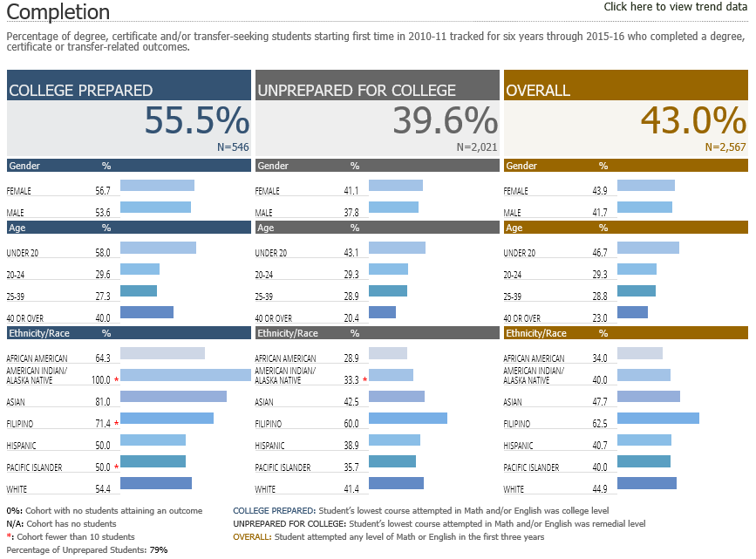

Student Learning and Outcomes Assessment
Please review your Learning Outcomes data located on the MJC Student Learning Outcomes Assessment website in regards to any applicable Program, Institutional, and General Education Learning Outcomes. After you have examined your rates and disaggregated data, reflect on the data you encountered. Please address your Administrative Unit Outcomes (AUO) and the College Institutional Learning Outcomes (ILO) in your analysis.

Administrative Unit Outcomes (AUO)
Examine your disaggregated Administrative Unit Outcomes and provide a brief synopsis of the data.

Institutional Learning Outcomes (ILO)
Examine the overall College disaggregated Institutional Learning Outcomes and provide a brief synopsis of the data.

Analysis, Planning and Continuous Quality Improvement: AUOs and ILOs
After analyzing the above data, provide plans for improvement. How you does your administrative area plan on addressing issues of equity and success in AUOs and ILOs? How does your area plan on closing learning gaps across student populations?

Program Analysis

Program Personnel
Provide a narrative or diagram of your division and personnel. Report any recent changes and any future personnel planning.

Faculty
Institutional Research will supply faculty names, no need to type

Please supply non-Faculty staff in your department with their position, and if FT / PT / 10 month, etc.

Division Productivity Measurements
Examine your division rates in the Productivity Dashboard. A picture of this dashboard will be supplied by Research and Planning. Provide an analysis of the rates over the last two years. Include future goals, areas for improvement, and strategies the division will employ to improve productivity.

Long Term Planning and Resource Needs

Long Term Planning
Provide a long-term outlook for your division, including any goals addressing equity, success, enrollment, or any additional information that hasn't been addressed elsewhere in this program review. You may include environmental scans for opportunities or threats to your program, or an analysis of important subgroups of the college population you serve. Taking into account the trends within this division and the college, describe what you realistically believe your program will look like in three to five years, including such things as staffing, facilities, enrollments, breadth and locations of offerings, etc.

Resource Request and Action Plan
Priority | Name | Resource Type | Estimated Cost | Objective

Evaluation of Previous Resource Allocations
Below is a list of resource allocations received in previous Program Reviews. Please evaluate the effectiveness of the resources utilized for your program. How did these resources help student success and completion? (https://www.mjc.edu/governance/rac/documents/ielmallocationsummary20142015.pdf)
The Evaluation / Measured Effectiveness can be typed in another program and pasted here, or typed directly in to the box below. The box will expand with additional text, and paragraphs (hard returns) can be added by using Ctrl+Enter.
Resource Allocated | PR Year | Evaluation / Measured Effectiveness

Career Technical Education Questions
The following series of question focus on Career and Technical Education, and can be answered using the labor data from Cal-PASS Plus on Launchboard. You will need to create an account before accessing the Launchboard.

How many students did you serve in the last two academic years?
(See Program Snapshot Reports > Where are students taking courses in the region > student)

What kinds of students are you serving?
(See Program Snapshot Reports > Where are students taking courses in the region > Check Categories)

What percentage of your students are persisting? Consider within the program and within the college.
(See Program Snapshot Reports > Are students progressing the pathway? > Term-to-Term Retention and Persistence)

Are students getting and keeping jobs?
(See Program Snapshot Reports > Are students getting jobs?)

What percentage of students are attaining a living wage?
(See Program Snapshot Reports > Are Students Making Reasonable Wages? > Living Wages button)

Appendix

Optional Questions
Please consider providing answers to the following questions. While these are optional, they provide crucial information about your equity efforts, training, classified professional support, and recruitment.
What strategies do you use to recruit, support and retain students from disproportionately impacted groups?

Does your division (or program) provide any training/mentoring for faculty to support the success of students at risk of academic failure?

Is there a need for more classified professional support in your area, please describe this need. Indicate how it would support the college mission and college goals for success, and completion.

What factors serve as barriers to recruiting active faculty to your program(s)?

Review Process Feedback
Please share any recommendations for improvements in the Program Review process, analysis, and questions. Your comments will become part of the permanent review record.

Executive Summary
Provide an executive summary of the findings of this program review. Your audience will be your Division Program Review Group, the MJC Program Review Workgroup, and the various councils of MJC.

