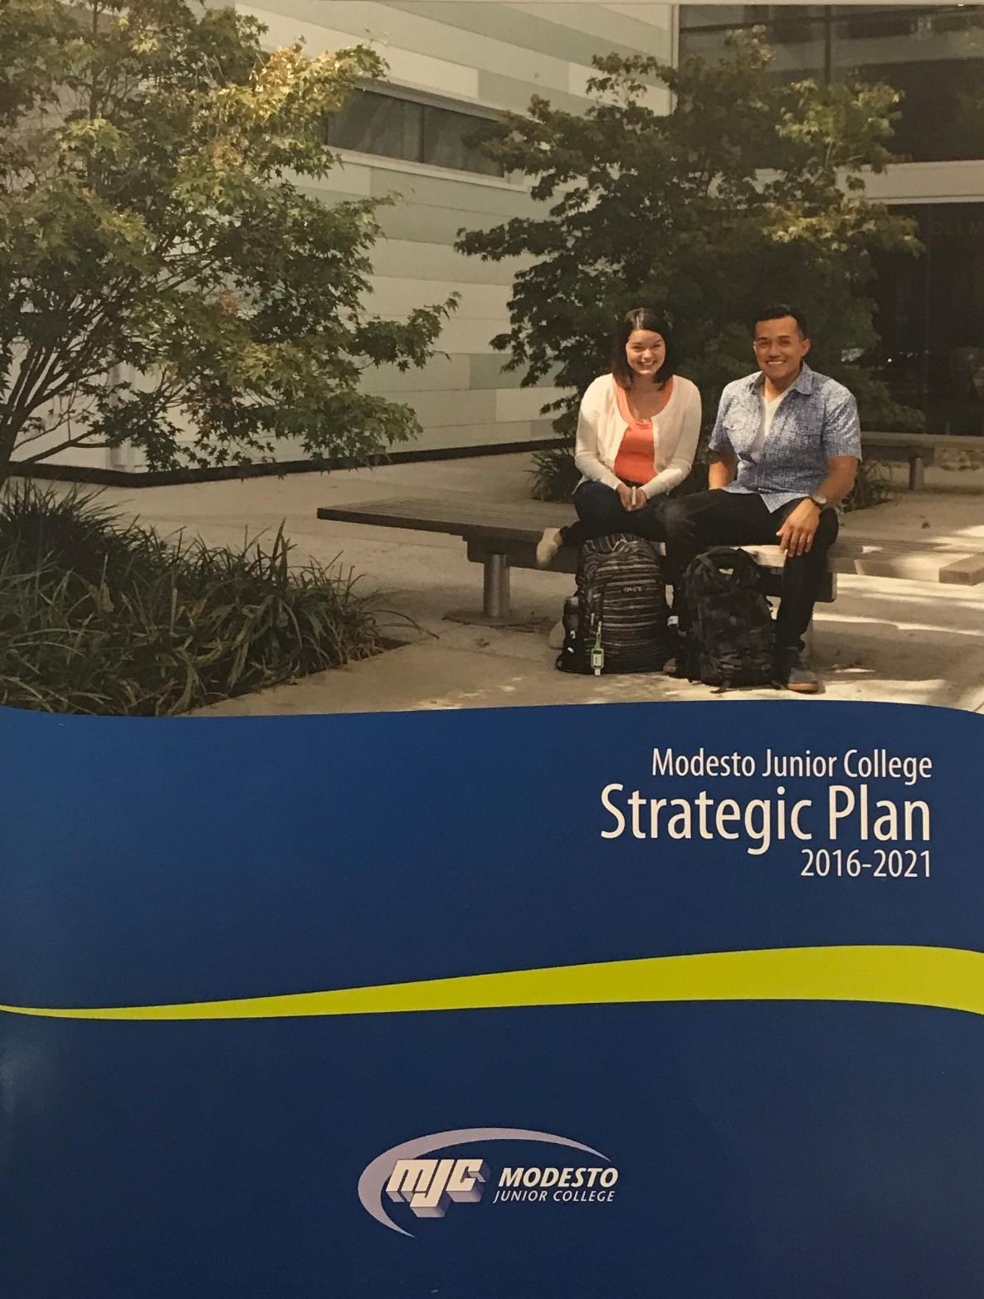
TRIO Student Support Services Program Review
June 2017

Modesto Junior College

Student Services Area Program Review
August 2017
Contents
Student Services Area Overview 2
The Mission of Modesto Junior College 2
Program Overview 2
Student Achievement and Completion 3
College Goal for Student Achievement Increase Scorecard Completion Rate for Degree and Transfer 3
Success 3
Student Learning and Outcomes Assessment 4
SSLO, SAO, and ILO Assessment 4
Additional Support Service Area Program Data (optional) 5
Additional Program Data 5
Program Analysis 6
Program Personnel 6
Long Term Planning and Resource Needs 7
Long Term Planning 7
Resource Request and Action Plan 7
Evaluation of Previous Resource Allocations 7
Appendix 8
Optional Questions 8
Review Process Feedback 8
Executive Summary 9

Student Services Area Overview

The Mission of Modesto Junior College
MJC is committed to transforming lives through programs and services informed by the latest scholarship of teaching and learning. We provide a dynamic, innovative, undergraduate educational environment for the ever-changing populations and workforce needs of our regional community. We facilitate lifelong learning through the development of intellect, creativity, character, and abilities that shape students into thoughtful, culturally aware, engaged citizens.
Provide a brief overview of the student services area and how it contributes to accomplishing the Mission of Modesto Junior College. (Overview Suggestions: How consistent is the student services area with the institutional mission, vision, core values and/or goals? How are aspects of the institutional mission addressed within the student services area? Is the student services area critical to the pursuit of the institutional mission?)
The purpose of the federally funded TRIO Student Support Services program is to provide academic and other support services to low-income, first-generation and/or students with disabilities. Program's objectives are to increase student retention and graduation rates, facilitate transfer from two-year to four-year universities, and foster an institutional climate supportive of the success of low-income and first-generation college students and individuals with disabilities.
Funded by the U. S. Department of Education, the TRIO Student Support Services goals are to ensure graduation, retention, and transfer rates of program participants.
One program goal includes a plan to inform the institutional community of the program goals, objectives, and services as well as the eligibility requirements for potential participants.
The second goal plans to identify, select and retain 258 participants with academic need, need for supportive services, and monitor academic progress using the following methods:
- The TRIO Pipeline Guidance Course
- Campus Referrals
- Presentations at Campus-Sponsored Activities
- Student Self-Referrals
The program has maintained the six to eight semester graduate and transfer objective.
The third goal is to plan for assessing individual needs and monitoring academic progress. Participants will answer a needs survey that identifies areas where assistance is needed such as tutoring, academic advising, financial aid, computer skills, and test-taking skills. Each student will develop a Comprehensive Educational Plan during the first semester of enrollment.
The final fourth goal, plan to provide services that address project goals and objectives. To ensure proper and efficient administration of the federal grant.

Program Overview
Please briefly list the core student support services provided by this area.
The program serves a minimum of 258 students and offers the following services: personal, academic, and career counseling; academic and career workshops; college campus visits, cultural events; priority registration; financial aid and scholarship assistance; grant aid; and assistance with completing admissions application and (TAG) transfer admissions guarantee to a four year college.
We encourage our students to be more involved in club activities. TRIO SSS students have taken the responsibilities of presidents or vice-presidents of various campus clubs. Some have become ASMJC Executive Officers and we had many ASMJC Senators this year. The experience gained from these positions was invaluable. Experience that can also be shared as they apply to the University of California via their personal statement now known as Personal Insight Questions and extra-curriculum activities.
For the year 2015-16 we had over 50 graduating and/or transfer students. In an average of 20% of participants finished within two years with our program. Our participants obtain acceptance to various UC's, CSUs and Private and out of state universities. 100% of our population also have completed comprehensive educational plans administered by Program Counselor/Coordinator who also serves as the Program Director for the 2015-2020 grant cycle.
For the year 2017-18 we are projecting to have over 60 students graduating and transferring to a 4-year university. Various workshops were offered targeting the needs of the students. Following find list of 2016-17 activities & workshops:
Fall Activities:
- Welcome Day
- UCSB Admissions Presentation
- Canvas 101
- New Student Advising Session
- Career Talk: Biology
- Campus Visit: Sacramento State
- UC Transfer Admission Planner Session
- Campus Visit: CSU Stanislaus
- Scholarship Workshop
- Advising Session
- FAFSA Workshop (2)
- Career Talk: Business, Leadership
- Campus Visit: UC Davis
- Campus Visit: Stanford University
- CSU Application Session
- UC Application Session
- Advising Session
- Career Talk: Psychology and Sociology
- Campus Visit: University of the Pacific
- Dress for Success Workshop (2)
- Advising Session
- Test Anxiety/Stress Management Workshop
- Holiday Social
Spring Activities:
- Tips for Taking Online Courses
- Discover your Learning Style
- I applied to CSU and UC, What’s Next Session
- Easy Tips to Over Come Stress
- Advising Session
- CSU Stanislaus Teacher Recruitment & Retention
- Transfer Requirements 101 Session
- Career Talk: Communication Studies
- DeepTok: Conversation with Dr. Delia Silva, Clinical Psychologist & Neuropsychologist “Live Webinar”
- Career Talk: Kinesiology
- Advising Sessions
- DeepTok: Conversation with Ms. Orly Liba, Experienced Electrical Engineer
- Financial Literacy: Money Matters
- Degree Audit Session
- Stanislaus TRIO SSS Information Session
- DeepTok: Your Look, Sound and Actions, Dr. Jane Binger
- UC Transfer Admission Planner Session
- DeepTok: Conversations with Dr. Namory Bagayoko, Orthopedic Surgeon
- End of the Year Celebration
- Campus Visit: CSU Monterey Bay
- DeepTok: Growing Your Resources, Connections, Ms. Liz Ramos, CEO/Founder Engeniate
- Career Talk: Early Childhood Education

Student Achievement and Completion

College Goal for Student Achievement
Increase Scorecard Completion Rate for Degree and Transfer
The College has a primary aspirational goal of increasing the Completion rate from 43% to 53% on the CCCCO Scorecard Completion Rate for Degree and Transfer [view] by 2022. The completion rates in the Scorecard refers to the percentage of degree, certificate and/or transfer-seeking students tracked for six years who completed a degree, certificate, or transfer-related outcomes (60 transfer units).
As you answer the questions below, please consider how your student services area is helping the college complete this aspirational goal of increasing the MJC Degree, Certificate, and Transfer Completion rate by 10% on the CCCCO Scorecard by 2022.

Success
The following questions refer to data produced by the MJC Office of Institutional Effectiveness, and may also pull from the Success Rate Data Dashboard, the CCCCO scorecard, and the Program Awards Dashboard.
After examining your student services area data, are these rates what you expected? Are there any large gaps? Is there anything surprising about the data? What do you see in the data?
The TRIO Student Support Services (SSS) program has been in existence at MJC since 1997 and this federal grant has been approved and funded every 5-year cycle. TRIO SSS has continue to provide all services mentioned during the 2016-17 academic year with the goals to meet all program objectives and goals. Our program objectives are as follows:
Objective A: Persistence Rate (2-year institution): 85% of all participants served in the reporting year by the SSS project will persist from one academic year to the beginning of the next academic year or earn an associate’s degree or certificate at the grantee institution and/or transfer from a 2-year to a 4-year institution by the fall term of the next academic year.

Objective B: Good Academic Standing Rate (2-year institution): 65% of all enrolled SSS participants served will meet the performance level required to stay in good academic standing at the grantee institution.

Objective C: Graduation and Transfer Rates (2-year institutions only) 70% of new participants served each year will graduate from the grantee institution with an associate’s degree or certificate within four (4) years; AND 70% of new participants served each year will receive an associate’s degree or certificate from the grantee institution and transfer to a four-year institution within four (4) years.

If there are differences in success across groups, how will your student services area help to close achievement gaps across student populations, and how will it contribute to overall success? In other words, how do you plan on closing achievement gaps across student populations and raise completion/degree rates? How will your area help to increase the CCCCO Scorecard Completion rate to 53%?
Our program has successfully been meeting its program objectives. According to our Annual Performance Report (APR), the following data demonstrates the last two program cycles in accordance with increasing the college completion rate goal.

Student Learning and Outcomes Assessment
Please review your Learning Outcomes data located on the MJC Student Learning Outcomes Assessment website in regards to any applicable Program, Institutional, and General Education Learning Outcomes. After you have examined your rates and disaggregated data, reflect on the data you encountered. Please address your Student services Unit Outcomes (AUO) and the College Institutional Learning Outcomes (ILO) in your analysis.

SSLO, SAO, and ILO Assessment
Support Service Learning Outcomes (SSLO) and Service Area Outcomes (SAO)
Review and provide a synopsis of your disaggregated SSLO and SAO data. What is your set goal for SSLO and SAO success? Do your overall rates meet this goal?
The following are our SAO and SLOs:
SAO: By spring semester, faculty and staff will use a student survey to access tutoring services and computer lab productivity and availability to drive the changes that we will make as a program. This will help students graduate and transfer to a four year institution in two years.

SSLO 1: Students will be able to understand the CSU and UC admissions/transfer requirements and be able to select the UC or CSU campus that best fits their educational goal and needs.
SSLO 2: Students will be able to understand Student Financial Aid awards and Pell grant requirements.
SSLO 3: Students will be able to understand the CSU Online Admissions Applications process.

Assessment Summary:
In the Fall 2015, the SSLO 1, SSLO 2 and SSLO 3 Learning Outcomes were assessed. Finding of the SSLOs are as follows:

Transfer Requirements to CSU and UC Workshop
Pre-Survey 73% answered questions correctly
Post-Survey 81% answered questions correctly

Financial Aid Workshop:
Pre-Survey 68% answered questions correctly
Post-Survey 97% answered questions correctly

CSU Online Admissions Application Workshop:
Pre-Survey 36% answered questions correctly
Post-Survey 83% answered questions correctly

The SAO was assessed based on the availability of a computer.
Over 90% of our TRIO SSS students have access to a computer and internet for school and personal needs. Our center also has a small computer lab accessible only to TRIO SSS students on a walk-in basis with no-cost to print assignments.

Institutional Learning Outcomes (ILO)
Review and provide a synopsis of your disaggregated ILO data. What is your set goal for ILO success? Do your overall rates meet this goal?

Equity, Success, and Continuous Quality Improvement
If your rates for success for any SSLOs, SAOs, and ILOs are lower than your goals, what are your plans to improve them? Additionally, do your rates for your SSLOs, SAOs, and ILOs vary across student populations? How you do you plan on addressing issues of equity? In other words, how do you plan on closing the learning gaps across student populations?
N/A

Additional Support Service Area Program Data (optional)

Additional Program Data
You may be asked to include additional data—or want to include additional data—regarding your service area. Please include your data below or attach it to your program review, set a goal regarding your data that would indicate success, and develop a plan for any improvements.
Additional Program Data
Please include your data in the box below or via an attachment. Write a brief description of the data, why it is important, and what it shows about your program. If you have different data sets, please identify and write about them separately.
Annually in December, our program completes the U.S. Department of Education Annual Performance Report (APR) tracking program outcomes. Last December 2015, the APR 2014-15 outcomes and objectives were met according to the grant's ambitious goals. Data for 2016 year is not yet available.

Data for the previous year (2013-14) is as follows:
Academic Standing Approved Rate: 75% Academic Standing Attained Rate: 85%
Persistence Approved Rate: 85% Persistence Attained Rate: 86%
Graduation Approved Rate: 65% Graduation Attained Rate: 65%
Transfer Approved Rate: 65% Transfer Attained Rate: 95%

NOTE: New grant cycle (2015-2020) the Counselor/Coordinator (Faculty) is also serving as the Program Director.

Analysis
Given the data you have provided, provide a set goal for success regarding the data, review your data, and provide a plan for improvement if needed. Also examine whether or not your data and rates vary across student populations. Discuss how you plan to address issues of success and equity.
In the previous program cycles TRIO SSS worked with Research and Planning to develop survey monkey in order to survey student. We continue to survey every workshop, campus visit, or event for continuous program improvement in order to achieve student success.

Program Analysis

Program Personnel
Provide a narrative or diagram of your area and personnel. Report any recent changes and any future personnel planning.
At the beginning of the Spring 2016 semester, TRIO SSS experienced a separation of the Program Technician due to career advancement/promotion. Glen Stovall, Program Technician, who had been with the program for over 12 years was crucial to the program success. At the end of the spring 2016 semester, Tira Lawhorn was hired as a replacement for the Program Technician. Before the beginning of the Spring 2017 semester, Tira transferred to a Columbia College position leaving a primary and fundamental position open once again for the program’s success. At the end of the Spring 2017 semester, Carolina was hired as the new Program Technician and has been with the program since then.
At the end of the Fall 2016 semester, the Administrative Technician, Laura Valencia Baez also separated from the college for a promotion and career advancement leaving this crucial position unfilled. Rebecca Tilger was hired as the new Administrative Assistant at the beginning of Fall 2017 semester.
List of names and titles
- Claudia Ramirez, Counselor/Coordinator also Program Director, 100%
- Carolina Fredericksen, Program Technician (New to program since April 2017), 100%
- Rebecca Tilger, Administrative Assistant (New to program since August 2017), 50%
- Student Workers, Peer Mentors, Tutors, Hourly, average of 10 to 15 hours per week

Long Term Planning and Resource Needs

Long Term Planning
Provide a long-term outlook for your student services area, including any goals addressing equity, success, enrollment, or any additional information that hasn't been addressed elsewhere in this program review. You may include environmental scans for opportunities or threats to your program, or an analysis of important subgroups of the college population you serve. Taking into account the trends within this student services area and the college, describe what you realistically believe your program will look like in three to five years, including such things as staffing, facilities, enrollments, breadth and locations of offerings, etc.

The increased demand by students seeking to enter the program has provided staff and faculty to seek resources that will allow the program to accept more students. The need clearly exists. The opportunity for increased federal funding depends on the allocations made in the U.S. Department of Education. It is possible to seek more TRIO SSS specialized grants that focus on STEM, students with disabilities and Veterans. Partnership with other programs on or off campus may also assist the needs of our participants. Expand the resources by working closely with the Career Development and Transfer Center, Counseling Department, various departments and programs. Extending our pipeline with the CSU and UC universities that perhaps have the TRIO SSS program at their campuses. Also partnering with the CSU Stanislaus TRIO SSS program as we seek experienced peer mentors for our program.

With the addition of two new TRIO SSS grants, we will increase to 600 students. Increased program staffing will include two full-time tenured counseling faculty, one adjunct counselor, two program technicians/specialists, and two administrative assistants. Given the opportunity to submit more grant proposals can realistically plan to increase staff and faculty to serve more students. Therefore, the need for office space and a larger computer lab will be necessary.

In the meantime, increasing our Administrative Assistant from 47.5% to 100% full-time, 12-months would greatly benefit and impact our program.

An adjunct counselor to help meet the student demand of counseling hours alleviating the Counselor/Coordinator who is also the Director of the Program.

Resource Request and Action Plan
Priority | Name | Resource Type | Estimated Cost | Objective
1 | Food for TRIO SSS Celebrations |  | $1,300 | Due to unallowable costs, TRIO SSS is not able to expend funds on food for students attending our Welcome Day, Holiday Celebration and End of the Year Celebration where we acknowledge students completed their degrees and transferring to 4-year universities.
2 | Adjunct Counselor |  | $5000 | Alleviate Counselor to do Program Director management duties.
3 | Computer Lab |  | $3,000 | Increase our computer lab stations or update older computer (4 computers)
4 | Southern California Campus Tour |  | $5,000 | Expose low-income, first generation students to 4-year universities in southern California

Evaluation of Previous Resource Allocations
Below is a list of resource allocations received in previous Program Reviews. Please evaluate the effectiveness of the resources utilized for your program. How did these resources help student success and completion? (https://www.mjc.edu/governance/rac/documents/ielmallocationsummary20142015.pdf)
The Evaluation / Measured Effectiveness can be typed in another program and pasted here, or typed directly in to the box below. The box will expand with additional text, and paragraphs (hard returns) can be added by using Ctrl+Enter.
Resource Allocated | PR Year | Evaluation / Measured Effectiveness
N/A

Appendix

Optional Questions
Please consider providing answers to the following questions. While these are optional, they provide crucial information about your equity efforts, training, classified professional support, and recruitment.
What strategies do you use to recruit, support and retain students from disproportionately impacted groups?
RECRUIT STUDENTS:
- Classroom presentation such as COLSK 100, GUIDE 110, GUIDE 111, GUIDE 120
- Pop-Up Outreach Table at various campus events staffed by Peer Mentors, Program Technician, etc.
- Posters, flyers, postcards
- Personalized invitation for potential students to participate
- Pipeline coming from TRIO Pre-College Students
- Email Counselors, Professors, Administrators inviting their students to apply for program
SUPPORT AND RETAIN STUDENTS:
- Constant contact with participants
- Have students sign a contract Mutual Student Agreement
- Attend workshops pertaining to their needs
- Assess students constantly, know their needs
- Explain the financial aid process, it is not just the application
- Plan their education to help students see how long it will take to get to the next phase
- Monitor their progress
- Celebrate their progress and accomplishments
- Tailor workshops based on the evaluations and surveys

Does your student services area (or program) provide any training/mentoring for faculty to support the success of students at risk of academic failure?

Is there a need for more classified professional support in your area, please describe this need. Indicate how it would support the college mission and college goals for success, and completion.
Our program currently is able to support a 50% Administrative Assistant position. Our need is to have this position at 100% to meet the demands of our participants. This position will help make more contact with our students and follow-up more often as this is crucial to maintain our retention, academic and graduation/transfer rates. This will assist with the college’s goal of graduation and transfer goals as well as retention.

What factors serve as barriers to recruiting active faculty to your program(s)?
N/A

Review Process Feedback
Please share any recommendations for improvements in the Program Review process, analysis, and questions. Your comments will become part of the permanent review record.

Executive Summary
Provide an executive summary of the findings of this program review. Your audience will be you’re the Student Services Division Program Review Group, the MJC Program Review Workgroup, and the various councils of MJC.
The TRIO SSS program has been in existence for many years at Modesto Junior College. Our program has many successful outcomes pertaining mainly to first-generation, low-income students along with students with disabilities.

Program has greatly impacted many transfer students who have successfully transferred and met their academic and personal goals. College being a Hispanic Serving Institution (HSI) and student population continue to increase, it is anticipated that the TRIO SSS services will continue to be in high demands and will continue to increase in the years to come. With proper resources the program will be able to adjust with the need in order to provide more services to the highest need students.

There is potential for growth, therefore the need for adequate facilities is anticipated to increase. In order to continue to meet our set program objectives, the college needs to continue to provide Priority Registration to program participants as this will also facilitate the other components of the program.

State mandated Priority Registration is requested, Level 1 for TRIO SSS participants.

