June 2017
Math / English
Program Review

Modesto Junior College

Math/English Program Review
June 2017
Contents
Program Overview 2
Program Overview 2
Response and follow-up to previous program reviews 2
The Mission of Modesto Junior College 3
Student Achievement and Completion 4
College Goal for Student Achievement 4
Success 4
Conferred Award Trends 5
Developmental Education 6
Achievement Rate for time to complete transfer level 6
Student Learning Outcomes 7
Student Learning and Outcomes Assessment 7
Curriculum and Course Offerings Analysis 9
Curriculum Analysis 9
Course Time, Location and Modality Analysis 10
Program Analysis 11
Program Personnel 11
Faculty Assignments 11
Departmental Productivity Measurements 11
Long Term Planning and Resource Needs 12
Long Term Planning 12
Resource Request and Action Plan 12
Evaluation of Previous Resource Allocations 12
Appendix 13
Optional Questions 13
Review Process Feedback 13
Executive Summary 14

Program Overview
Instructions
Supplemental information, links to previous reviews, and dashboards can be accessed from the review, please ensure your pop-up blocker is turned off, or use Ctrl-Click to bypass it.
Please review each question below, following the prompts and links given in the help text. Additional help, and a list of frequently asked questions is available on the Program Review Instructions page.

Program Overview
Please list program awards that are under this department according to the college catalog. Next to each program award listed;
- Please denote if it should be included here, or should be listed elsewhere.
- Answer yes or no, if the program has external regulations
- Additional lines, if needed, may be added by typing the tab key while in the last cell
- Any additional notes can be added in the box below the table
[addl help]
Program Awards | Include in Review (yes/no) | External Regulations (yes/no)

Response and follow-up to previous program reviews
On the Curricunet website, please locate your department and the previous program review. After reviewing, please complete the following questions;
Briefly describe the activities and accomplishments of the department since the last program review.

The Mission of Modesto Junior College
MJC is committed to transforming lives through programs and services informed by the latest scholarship of teaching and learning. We provide a dynamic, innovative, undergraduate educational environment for the ever-changing populations and workforce needs of our regional community. We facilitate lifelong learning through the development of intellect, creativity, character, and abilities that shape students into thoughtful, culturally aware, engaged citizens.
Provide a brief overview of the program and how it contributes to accomplishing the Mission of Modesto Junior College. (Overview Suggestions: How consistent is the program with the institutional mission, vision, core values and/or goals? How are aspects of the institutional mission addressed within the program? Is the program critical to the pursuit of the institutional mission?)

Student Achievement and Completion

College Goal for Student Achievement
Increase Scorecard Completion Rate for Degree and Transfer
The College has a primary aspirational goal of increasing the Completion rate from 43% to 53% on the CCCCO Scorecard Completion Rate for Degree and Transfer [view] by 2022. The completion rates in the Scorecard refers to the percentage of degree, certificate and/or transfer-seeking students tracked for six years who completed a degree, certificate, or transfer-related outcomes (60 transfer units).
As you answer the questions below, please consider how your program is helping the college complete this aspirational goal of increasing the MJC Degree, Certificate, and Transfer Completion rate by 10% on the CCCCO Scorecard by 2022.

Success
The following questions refer to data from the Department Success Rates Dashboard. Use the filters to examine both departmental and course level data. Charts will be included for the record by Research and Planning once the review is submitted.
Locate your department success rates on the Success Rate Data Dashboard and consider your department success rates trends over time, especially the last two years. Also, consider the data detailing the variance of success rate of courses across sections. Are these rates what you expected? Are there any large gaps? Is there anything surprising about the data? What do you see in the data?

What is your set goal for success? Do your department and individual course rates meet this goal?

If your rates for success are lower than your goals, what are your plans to improve them?

Locate your department equity rates on the Success Rate Data Dashboard (by pressing on the equity tab). Examine these rates, disaggregated by ethnicity and gender, over the last two years. If there are differences in success across groups, how do you plan on addressing issues of student equity? In other words, how do you plan on closing achievement gaps across student populations?

If distance education is offered, consider any gaps between distance education and face-to-face courses. Do these rates differ? If so, how do you plan on closing the achievement gaps between distance education and face-to-face courses?

Conferred Award Trends
Review the Program Awards Dashboard, using the drop-down filters to focus the analysis on your department. Starting with identifying the year, please supply degrees and certificates awarded. These charts will be attached by Research and Planning before being posted publicly.
What is your set goal for degrees and certificates awarded? Do your rates meet this goal?

If your rates for degrees and certificates awarded are lower than your goals, what are your plans to improve them?

Developmental Education
For our programs that address developmental education (Math/English), please review the CCCCO Scorecard data on Transfer Level Achievements, then answer below.

Achievement Rate for time to complete transfer level
Using the data from the CCCCO Scorecard,(Transfer Level Achievement Tab) what is your achievement rate for time to complete transfer-level course work (one year and two year)?
What is your departmental goal for each of these rates? Are you meeting these goals? If not, how are you addressing meeting your goals?

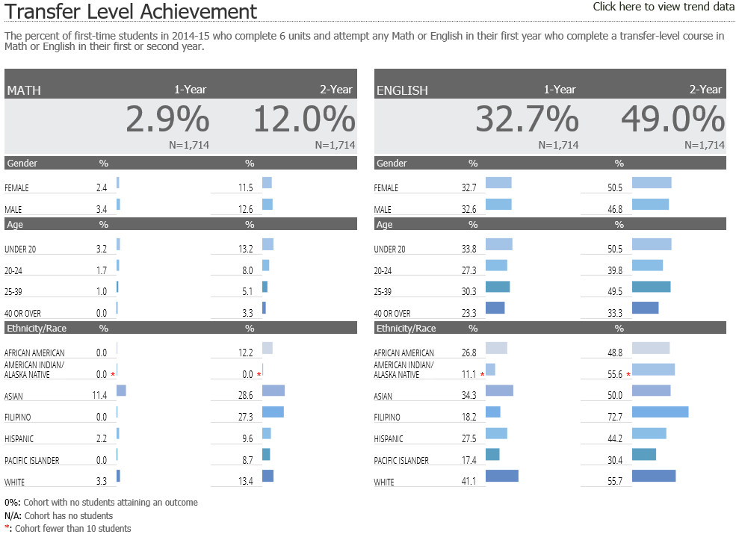
Source: CCCCO. (2017). Scorecard: Transfer Level Achievement [Dashboard Graphic],
Retrieved from http://scorecard.cccco.edu/scorecardrates.aspx?CollegeID=592#home

Student Learning Outcomes
Instructions
This section of the Program Review measures student learning.
PLO / GELO / ILO Outcomes
To ease in analysis, trending charts have been created by Research and Planning on the Learning Outcomes Dashboard website. Using these charts, you can identify your current success rates in student achievement towards the outcomes. Considering your current outcome success rates, and previous semester, set a department aspirational goal, and examine what your outcome success rates are currently. Later you will be asked to outline a plan to achieve this threshold, but for now, simply supply the Goal % and Current % for each level.
Note: If the dashboards do not show your Learning Outcomes, please ensure that they have been mapped in eLumen. Each course will need to be mapped to each applicable PLO, GELO, and ILO. The Outcome Assessment Workgroup has created a web page detailing the work already done -> PLO, ILO, and GELO Assessment grids. For additional assistance, review the Course Learning Outcome Assessment web pages, or contact Nita Gopal at gopaln@mjc.edu.

Student Learning and Outcomes Assessment
Please review your Learning Outcomes data located on the MJC Student Learning Outcomes Assessment website and below, in regards to any applicable Program, Institutional, and General Education Learning Outcomes.
For each ILO that your course learning outcomes inform, you will find your overall rate. On the MJC Student Learning Outcomes Assessment website, you will also see that overall rate disaggregated across student populations; you can use this information to understand how different student populations are learning in your courses.
After you have examined your rates and disaggregated data, reflect on the data you encountered. Please address the program outcomes (PLO), general education outcomes GELO (if any), and institutional outcomes (ILO) in your analysis.

Program Learning Outcomes (PLO)
What is your set goal for PLO success? Do your overall rates meet this goal?

General Education Learning Outcomes (GELO)
If your program has General Education outcomes, what is your set goal for GELO success? Do your overall rates meet this goal?

Institutional Learning Outcomes (ILO)
What is your set goal for ILO success? Do your overall rates meet this goal?

Continuous Quality Improvement
If your rates for success for any PLOs, GELOs, and ILOs are lower than your goals, what are your plans to improve them?

Equity and Success
Do your rates for your PLOs, GELOs, and ILOs vary across student populations? How you do you plan on addressing issues of equity? In other words, how do you plan on closing the learning gaps across student populations?

Curriculum and Course Offerings Analysis

Curriculum Analysis
Courses that have not been reviewed, or not scheduled to be reviewed, are listed on the Curriculum Committee web pages. To aid in use, please view this filtered spreadsheet, using the drop down menus along the field headings, to view just your department. On opening the spreadsheet, click the Enable Editing and Enable content buttons that should appear across the top menu bar.
Considering those courses that have not been reviewed within the last five years, please address these below.
Provide your plans to bring courses into compliance with the 5-year cycle of review. If your department is compliant, please state that.

Provide your plans to either inactivate or teach each course not taught in the last two years.

Does the College Catalog accurately display the descriptions and requirements of all the courses and educational awards (degrees/certificates) overseen by this program? If not, please describe your plans to correct.

Are there plans for new courses or educational awards (degrees/certificates) in this program? If so, please describe the new course(s) or award(s) you intend to create.

What needs or rationale support this action, and when do you expect to submit these items to the Curriculum Committee?

Course Time, Location and Modality Analysis
Please follow this link and review the Course Attributes in regards to when, where, and in which method the courses in this program are taught. Use the filters to focus the report on your department. Then answer the following questions.
Location/Times/Modality Trend Analysis:
Consider and analyze your location, time, and modality trends. Discuss any program plans that address more efficient and beneficial location, modality and/or time of day trends.

Program Analysis

Program Personnel
Please refer to the Department Faculty and Sections Dashboard to supply the names of faculty and adjuncts for the periods requested. Use the dashboard filters to focus on your individual department. Due to the complexity of payroll accounts and assignments, those listed may not match known individuals, please note any discrepancies.
Additional comments or narrative can be added below.
Faculty Name | Full-Time or Part-Time (adjunct) | Hire Date (optional)

Faculty Assignments
Please refer to the Department Faculty and Sections Dashboard to supply the number of faculty and adjuncts for the past two years of regular terms. Use the dashboard filters to focus on your individual department. Due to the complexity of payroll accounts and assignments, those listed may not match known individuals, please note any discrepancies. Please note that summer positions are all shown as adjunct due to payroll categories.
Enter figures for each term, to add additional rows, click in last cell on right and push tab on the keyboard.
Additional comments or narrative can be added below.
Term (Year Term, e.g. 2016) | # Sections Offered / Term | # Taught by FT Faculty | # Taught by Other Faculty | Program Fill Rate %

Departmental Productivity Measurements
If not pre-filled, please complete for two years the following table of indicators, as listed on top of the Productivity Dashboard. A picture of this dashboard will be supplied by Research and Planning. Please enter one term per line; to add an additional line, click in last cell and use the Tab key.
The space below is available for comments and narratives.
Term (e.g. 2016 Fall) | FTEF | FTES | FTES/FTEF | WSCH/FTEF

Long Term Planning and Resource Needs

Long Term Planning
Provide any additional information that hasn't been addressed elsewhere in this program review, such as environmental scans for opportunities or threats to your program, or an analysis of important subgroups of the college population you serve.
View the Program Review Instructions page for reference and inspiration.
Taking into account the trends within this program and the college, describe what you realistically believe your program will look like in three to five years, including such things as staffing, facilities, enrollments, breadth and locations of offerings, etc.

Resource Request and Action Plan
Priority | Name | Resource Type | Estimated Cost | Objective

Evaluation of Previous Resource Allocations
Below is a list of resource allocations received in previous Program Reviews. Please evaluate the effectiveness of the resources utilized for your program. How did these resources help student success and completion? (https://www.mjc.edu/governance/rac/documents/ielmallocationsummary20142015.pdf)
The Evaluation / Measured Effectiveness can be typed in another program and pasted here, or typed directly in to the box below. The box will expand with additional text, and paragraphs (hard returns) can be added by using Ctrl+Enter.
Resource Allocated | PR Year | Evaluation / Measured Effectiveness

Appendix

Optional Questions
Please consider providing answers to the following questions. While these are optional, they provide crucial information about your equity efforts, training, classified professional support, and recruitment.
What strategies do you use to recruit, support and retain students from disproportionately impacted groups?

Does your division (or program) provide any training/mentoring for faculty to support the success of students at risk of academic failure?

Is there a need for more classified professional support in your area, please describe this need. Indicate how it would support the college mission and college goals for success, and completion.

What factors serve as barriers to recruiting active faculty to your program(s)?

Review Process Feedback
Please share any recommendations for improvements in the Program Review process, analysis, and questions. Your comments will become part of the permanent review record.

Executive Summary
Provide an executive summary of the findings of this program review. Your audience will be your Division Program Review Group, the MJC Program Review Workgroup, and the various councils of MJC.

