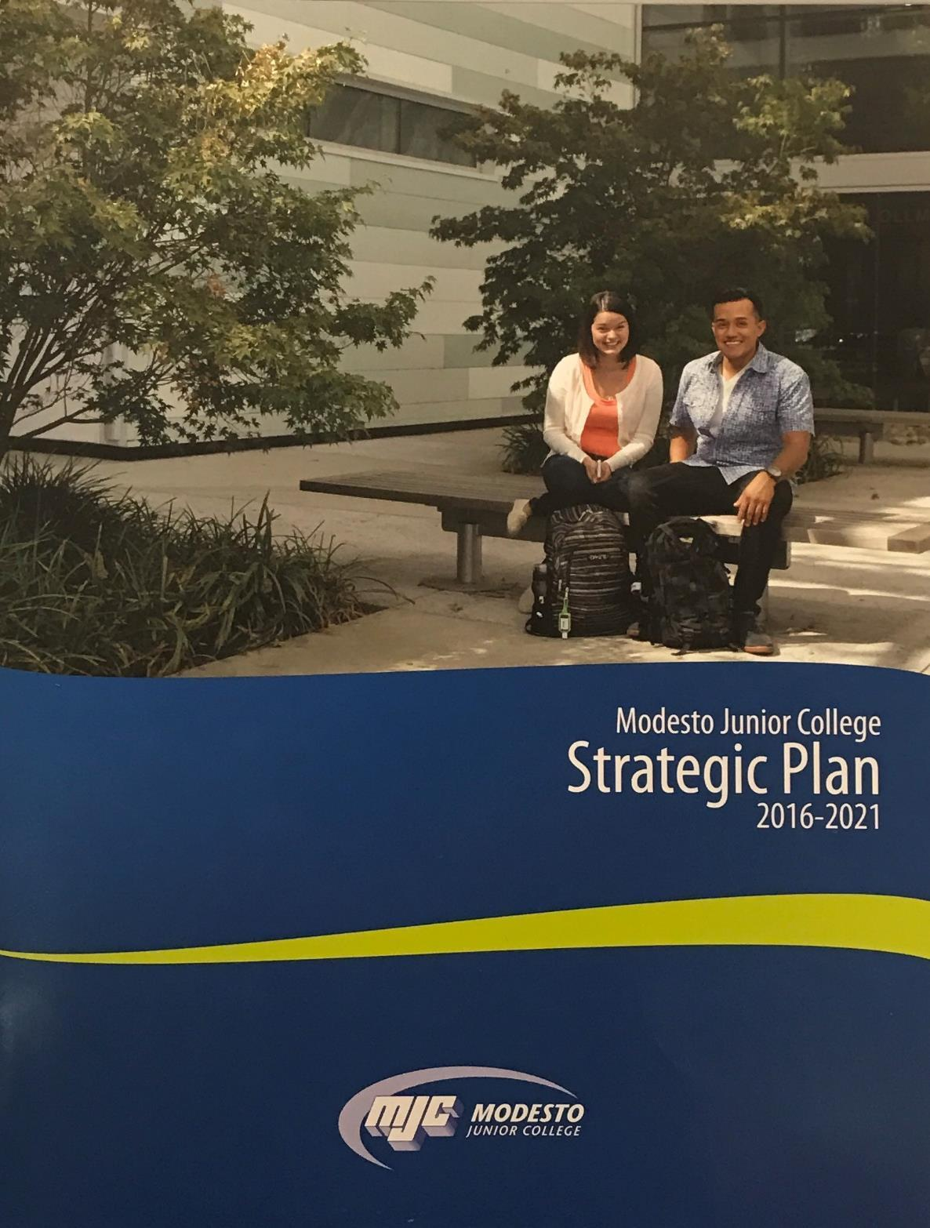
Geography
Program Review
June 2017

Modesto Junior College

Geography Program Review
June 2017
Contents

Program Overview 3
Program Overview 3
Response and follow-up to previous program reviews 4
The Mission of Modesto Junior College 4
Student Achievement and Completion 5
College Goal for Student Achievement 5
Success 5
Conferred Award Trends 6
Student Learning Outcomes 7
Student Learning and Outcomes Assessment 7
Curriculum and Course Offerings Analysis 9
Curriculum Analysis 9
Course Time, Location and Modality Analysis 10
Program Analysis 11
Program Personnel 11
Faculty Assignments 11
Departmental Productivity Measurements 11
Long Term Planning and Resource Needs 12
Long Term Planning 12
Resource Request and Action Plan 12
Evaluation of Previous Resource Allocations 12
Career Technical Education Questions 13
How many students did you serve in the last two academic years? 13
What kinds of students are you serving? 13
What percentage of your students are persisting? Consider within the program and within the college. 13
Are students getting and keeping jobs? 13
What percentage of students are attaining a living wage? 13
Appendix 14
Optional Questions 14
Review Process Feedback 14
Executive Summary 15

Program Overview
Instructions
Supplemental information, links to previous reviews, and dashboards can be accessed from the review, please ensure your pop-up blocker is turned off, or use Ctrl-Click to bypass it.
Please review each question below, following the prompts and links given in the help text. Additional help, and a list of frequently asked questions is available on the Program Review Instructions page.

Program Overview
Please list program awards that are under this department according to the college catalog. Next to each program award listed;
- Please denote if it should be included here, or should be listed elsewhere.
- Answer yes or no, if the program has external regulations
- Additional lines, if needed, may be added by typing the tab key while in the last cell
- Any additional notes can be added in the box below the table
[addl help]
Program Awards | Include in Review (yes/no) | External Regulations (yes/no)
AA-T Geography | yes | no

Response and follow-up to previous program reviews
On the Curricunet website, please locate your department and the previous program review. After reviewing, please complete the following questions;
Briefly describe the activities and accomplishments of the department since the last program review.
Since the last program review of the Geography program in 2016, we have hired new adjunct faculty, added more class sections as the program has grown, and created new curriculum to offer a physical geography lab course (in line with the state C-ID in geography). Geography was identified for funding through IELM monies in Spring 2017, enabling class simulations in the Physical Geography lab course.

The Mission of Modesto Junior College
MJC is committed to transforming lives through programs and services informed by the latest scholarship of teaching and learning. We provide a dynamic, innovative, undergraduate educational environment for the ever-changing populations and workforce needs of our regional community. We facilitate lifelong learning through the development of intellect, creativity, character, and abilities that shape students into thoughtful, culturally aware, engaged citizens.
Provide a brief overview of the program and how it contributes to accomplishing the Mission of Modesto Junior College. (Overview Suggestions: How consistent is the program with the institutional mission, vision, core values and/or goals? How are aspects of the institutional mission addressed within the program? Is the program critical to the pursuit of the institutional mission?)
Geography is a dynamic discipline that is central to the development of an engaged and culturally aware individual. Geography students consist of individuals planning to teach (Liberal Studies and Social and Behavioral Science program) and students who plan to obtain a business or economics degree. Physical geography courses fulfill natural science requirements and provide students with thorough comprehension of earth systems, enabling students to be educated in public policy issues on the environment (water, pollution, vegetation, and sustainable development) and critically analyze human interactions with the Earth. Other courses in geography are more political and culture in content, examining global patterns of demographics, language, religion, and ethnicity. These courses provide a framework for students to understand the diversity which is found on a global basis, and prepares them to see the impact such patterns may have upon global events, economic relationships, and future realities. Students who take geography courses are challenged to identify local, national, and global problems and propose solutions to these problems based upon their analysis and evaluation of strategies employed globally. Geography courses encourage students to think globally, creatively, and broaden their experiences through global research.

Student Achievement and Completion

College Goal for Student Achievement
Increase Scorecard Completion Rate for Degree and Transfer
The College has a primary aspirational goal of increasing the Completion rate from 43% to 53% on the CCCCO Scorecard Completion Rate for Degree and Transfer [view] by 2022. The completion rates in the Scorecard refers to the percentage of degree, certificate and/or transfer-seeking students tracked for six years who completed a degree, certificate, or transfer-related outcomes (60 transfer units).
As you answer the questions below, please consider how your program is helping the college complete this aspirational goal of increasing the MJC Degree, Certificate, and Transfer Completion rate by 10% on the CCCCO Scorecard by 2022.

Success
The following questions refer to data from the Department Success Rates Dashboard. Use the filters to examine both departmental and course level data. Charts will be included for the record by Research and Planning once the review is submitted.
Locate your department success rates on the Success Rate Data Dashboard and consider your department success rates trends over time, especially the last two years. Also, consider the data detailing the variance of success rate of courses across sections. Are these rates what you expected? Are there any large gaps? Is there anything surprising about the data? What do you see in the data?
The geography department has experienced an increase of student success by 6% over the last two years. Success rates improved from 55% in Fall 2014 to 61% in Fall 2016, and from 52% in Spring 2015 to 58% in Spring 2017. Online success rates continue to be lower (59% in Fall 2016) than face-to-face courses (63% in Fall 2016). There appears to be more consistent data with courses which are taught multiple times each semester, such as Geog 101 versus courses, such as Geog 105, which are taught once a semester with alternating modalities (face-to-face vs. online). Face-to-face courses appear to have been the primary cause for much of the increase in student success. This is a result of reducing large lecture courses in favor of single sections, stimulating more student discussion and peer-to-peer interaction in classes.

What is your set goal for success? Do your department and individual course rates meet this goal?
Overall, our goal is to see 60% success for each course taught in Geography. We will examine the modality and length of term in which we are offering courses in order to provide the most likely environment for student success. Expansion of course offerings tends to cause falling success rates, while tightening offerings increases student success, yet provides little opportunity or access for program and certificate completion.

If your rates for success are lower than your goals, what are your plans to improve them?
The geography department will continue to examine our student assignments and testing criteria. We will continue to create activities which stimulate classroom discussion and group activities which enable students to create support networks within courses and across the college. It would be great if we could disaggregate the data for sections by ethnicity, gender, and income in the CLO data. This would allow us to identify possible populations who are struggling with specific CLOs and locate learning strategies most able to help those students.

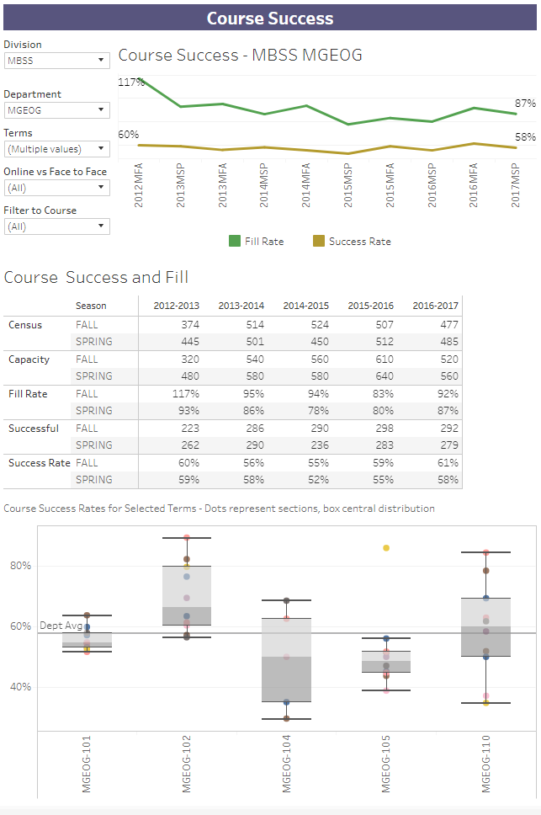
Locate your department equity rates on the Success Rate Data Dashboard (by pressing on the equity tab). Examine these rates, disaggregated by ethnicity and gender, over the last two years. If there are differences in success across groups, how do you plan on addressing issues of student equity? In other words, how do you plan on closing achievement gaps across student populations?
Students from four ethnic groups (African American, Asian, Filipino, and Hispanic students) and students declaring two or more ethnic identities, are performing below average in geography courses. The geography department has provided textbooks for use in the library reserve for students who cannot afford the text. Greater incorporation of student discussion and class activities have been integrated into the classroom in order to stimulate greater participation and engagement among all student groups and the instructor. Faculty have been utilizing constructive strategies, such as “cheerleading” student performance and celebrating successes more vocally in class. Additionally, faculty have been integrating student presentations in order to connect more fully to the cultural wealth possessed by all students.
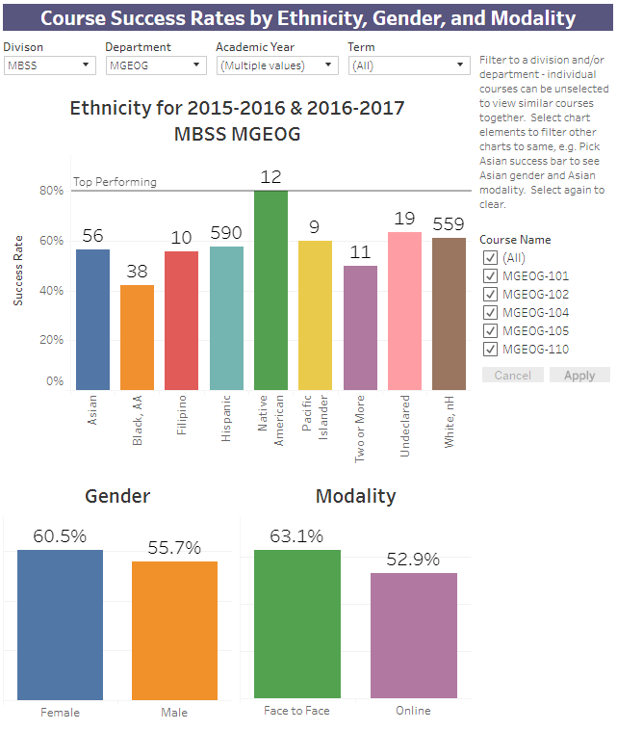

If distance education is offered, consider any gaps between distance education and face-to-face courses. Do these rates differ? If so, how do you plan on closing the achievement gaps between distance education and face-to-face courses?
The geography department is experiencing a 9% difference in success in online classes as compared to face-to-face classes. We will examine course assignments and expectations across all modalities to standardize performance expectations. In actuality, online students are required to complete more work on weekly basis. Cece experimented integrating weekly activities used successfully in online courses during the Fall 2016 semester, and found decreased success in face-to-face modalities when students were asked to participate in weekly activities. Additionally, geography has offered 4-5 short courses (5-8 weeks) over the past two years, and these courses demonstrate lower success than the traditional 16 week online semester. If there were free texts in geography for online students, success may increase. At this time, there are none.

Conferred Award Trends
Review the Program Awards Dashboard, using the drop-down filters to focus the analysis on your department. Starting with identifying the year, please supply degrees and certificates awarded. These charts will be attached by Research and Planning before being posted publicly.
What is your set goal for degrees and certificates awarded? Do your rates meet this goal?
For 2015-16 and 2016-2017, there was one degree awarded in geography. Our goal would be to average 5 degrees awarded per academic year.
If your rates for degrees and certificates awarded are lower than your goals, what are your plans to improve them?
We need to market the geography degree more fully on campus, such as creating flyers and program maps available to students on campus. Additionally, Cece and the adjunct faculty will facilitate greater contact between prospective geography majors and transfer institutions, such as UC Berkeley, CSU Stanislaus, CSU San Jose, CSU Monterey Bay, and San Diego State. Two of our current adjunct faculty work full-time at CSU Stanislaus which we hope will facilitate greater success of both programs.

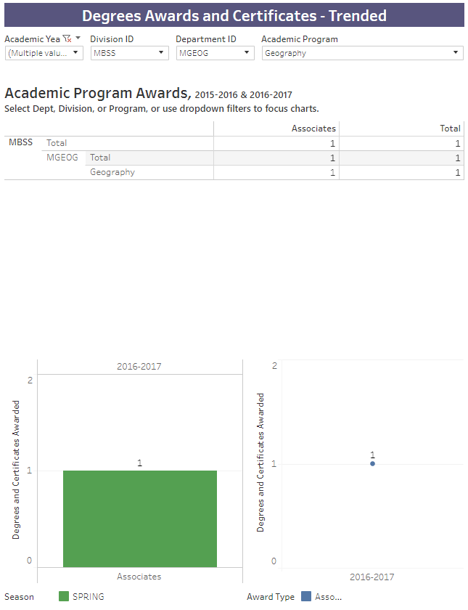
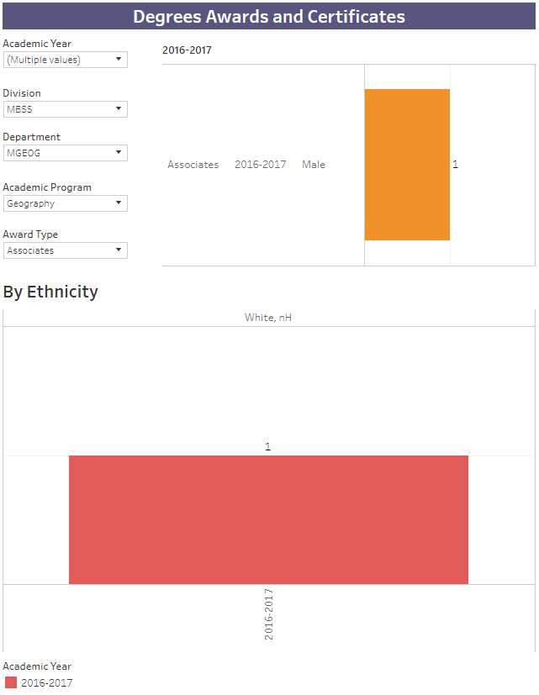

Student Learning Outcomes
Instructions
This section of the Program Review measures student learning.
PLO / GELO / ILO Outcomes
To ease in analysis, trending charts have been created by Research and Planning on the Learning Outcomes Dashboard website. Using these charts, you can identify your current success rates in student achievement towards the outcomes. Considering your current outcome success rates, and previous semester, set a department aspirational goal, and examine what your outcome success rates are currently. Later you will be asked to outline a plan to achieve this threshold, but for now, simply supply the Goal % and Current % for each level.
Note: If the dashboards do not show your Learning Outcomes, please ensure that they have been mapped in eLumen. Each course will need to be mapped to each applicable PLO, GELO, and ILO. The Outcome Assessment Workgroup has created a web page detailing the work already done -> PLO, ILO, and GELO Assessment grids. For additional assistance, review the Course Learning Outcome Assessment web pages, or contact Nita Gopal at gopaln@mjc.edu.

Student Learning and Outcomes Assessment
Please review your Learning Outcomes data located on the MJC Student Learning Outcomes Assessment website and below, in regards to any applicable Program, Institutional, and General Education Learning Outcomes.
For each ILO that your course learning outcomes inform, you will find your overall rate. On the MJC Student Learning Outcomes Assessment website, you will also see that overall rate disaggregated across student populations; you can use this information to understand how different student populations are learning in your courses.
After you have examined your rates and disaggregated data, reflect on the data you encountered. Please address the program outcomes (PLO), general education outcomes GELO (if any), and institutional outcomes (ILO) in your analysis.

Program Learning Outcomes (PLO)
What is your set goal for PLO success? Do your overall rates meet this goal?
Our goal for geography PLO success would be for all groups success rates to measure the course completion rates, roughly 60%. To reach that goal, we need to improve success with African Americans in assessing the relationship between humans and the environment, and the description of geographical methodology. Small increases are needed to see improvements with Filipino students on the outcome of the description of spatial patterns.
Out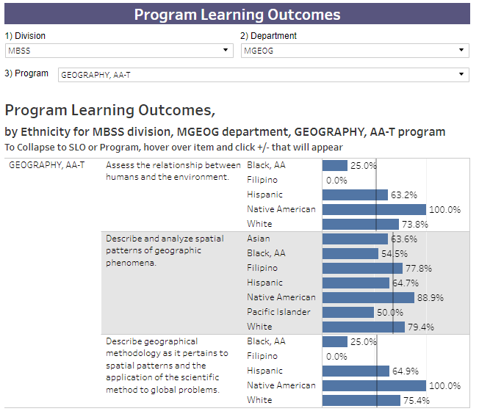
General Education Learning Outcomes (GELO)
If your program has General Education outcomes, what is your set goal for GELO success? Do your overall rates meet this goal?
Geography straddles both natural sciences and social sciences. The GELO success for social science are much higher than those for natural sciences. Our goal for both would be 60%. This will require improvements in the science GELO success found in our largest offerings, Geography 101.
Geo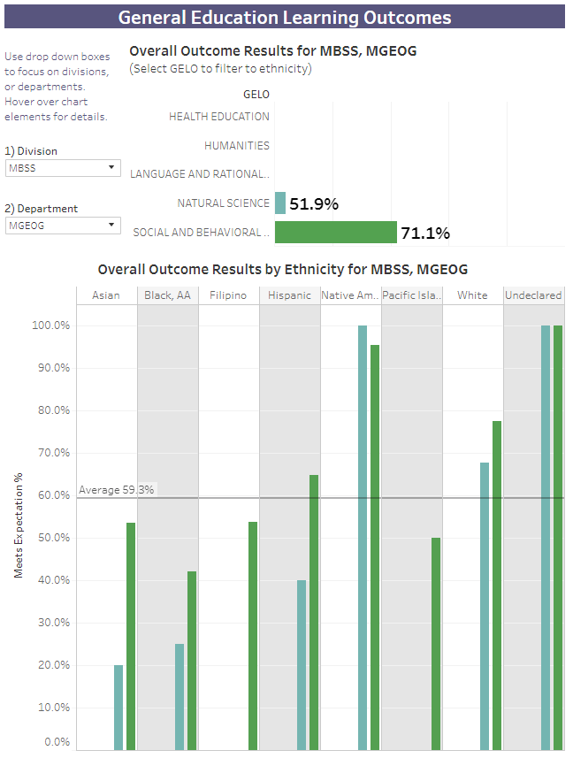

Institutional Learning Outcomes (ILO)
What is your set goal for ILO success? Do your overall rates meet this goal?
Our goal is to meet the average of 59.3% for all groups in ILO success. Our overall outcomes are very strong, yet we need to work with students in ethnic groups which are not reaching success in these areas.
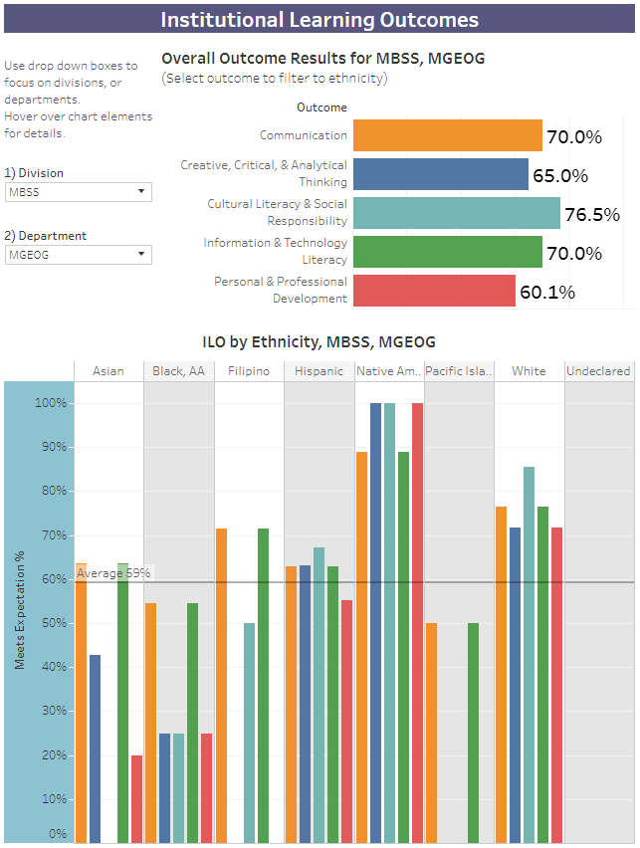
Continuous Quality Improvement
If your rates for success for any PLOs, GELOs, and ILOs are lower than your goals, what are your plans to improve them?
Geography has no pre-requisites for our courses. We have listed English 101 as “recommended for success” since the bulk of geographical study is descriptive analysis of global patterns. Yet, very few students come into our classes having completed English 101 prior to geography. As Guided Pathways are formed, we hope that students will take skill-building courses prior to transfer level geography courses, and we should see increased student success in PLOs, GELOs, and ILOs. After such skill pathways are developed, we will have a better understanding of which student populations need more attention in order to create student equity.

Equity and Success
Do your rates for your PLOs, GELOs, and ILOs vary across student populations? How you do you plan on addressing issues of equity? In other words, how do you plan on closing the learning gaps across student populations?
Yes. Our approach as a geography department has been one of open access, students can enroll in our classes without english, reading, or math assessment. It would be nice to disaggregate assessment data with course learning outcome data in order to identify possible correlations and gap areas within student populations. Greater tutoring opportunities and online text support could be utilized, yet we have been slow to assign such online sources due to the income limitations of our students ($50 beyond the textbook). It is surprising to see that students are not obtaining success in the area of cultural literacy and social responsibility as this tends to be a strong skill among millennial populations. Our courses will continue to role-model theories, terms, and historical examples which enable students to articulate their own cultural experience. Student assignments which require students to engage in their own community or the larger political structure of the region will serve to empower them.

Curriculum and Course Offerings Analysis
Saving your Work
Before clicking links to dashboards, please click the Save Draft button to save your work without submitting.

Curriculum Analysis
Courses that have not been reviewed, or not scheduled to be reviewed, are listed on the Curriculum Committee web pages. To aid in use, please view this filtered spreadsheet, using the drop down menus along the field headings, to view just your department. On opening the spreadsheet, click the Enable Editing and Enable content buttons that should appear across the top menu bar.
Considering those courses that have not been reviewed within the last five years, please address these below.
Provide your plans to bring courses into compliance with the 5-year cycle of review. If your department is compliant, please state that.
All courses in the Geography department are compliant, except for Geog 109, Introduction to GIS which we have not offered over the past 5 years. This course will be inactivated as it was identified at the Geography DIG meeting to be an upper division course.

Provide your plans to either inactivate or teach each course not taught in the last two years.
Please see comments above.

Does the College Catalog accurately display the descriptions and requirements of all the courses and educational awards (degrees/certificates) overseen by this program? If not, please describe your plans to correct.
Yes.

Are there plans for new courses or educational awards (degrees/certificates) in this program? If so, please describe the new course(s) or award(s) you intend to create.
Not at this time.

What needs or rationale support this action, and when do you expect to submit these items to the Curriculum Committee?
Geog 109 will be inactivated during the Fall 2017 semester.

Course Time, Location and Modality Analysis
Please follow this link and review the Course Attributes in regards to when, where, and in which method the courses in this program are taught. Use the filters to focus the report on your department. Then answer the following questions.
Location/Times/Modality Trend Analysis:
Consider and analyze your location, time, and modality trends. Discuss any program plans that address more efficient and beneficial location, modality and/or time of day trends.
The geography department has found (similar to college trends) that online courses are filling more consistently than face-to-face courses offered in the evenings. Additionally, as more sections were added to support college enrollment goals, more online sections were added during 2016-2017. Afternoon courses have not been as successful for geography enrollments, but we hope to offer geography lab sections from 2-4pm during the Fall 2018 semester. There were two large lecture courses offered in Spring 2017, and one section was reduced to a single as enrollments were soft in the Spring.

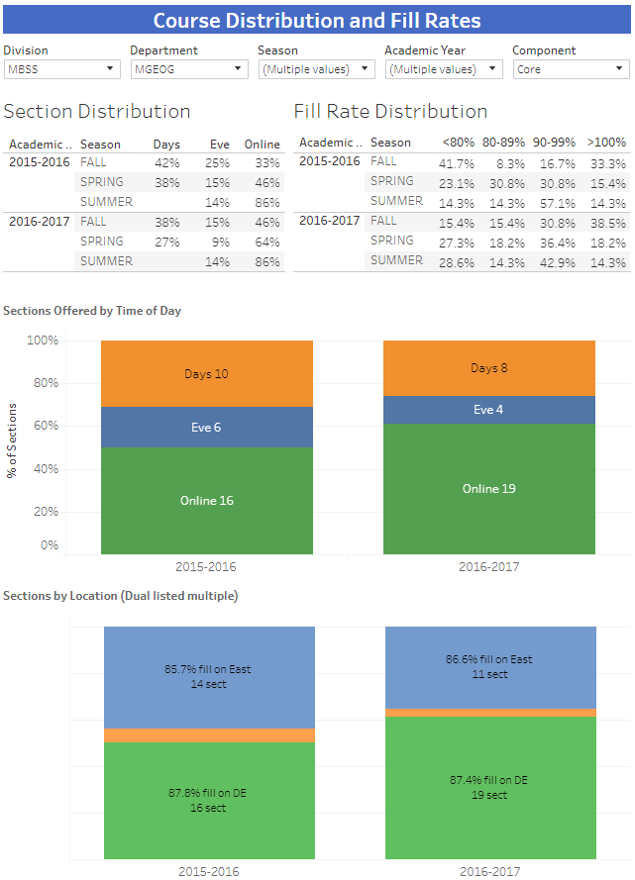

Program Analysis

Program Personnel
Please refer to the Department Faculty and Sections Dashboard to supply the names of faculty and adjuncts for the periods requested. Use the dashboard filters to focus on your individual department. Due to the complexity of payroll accounts and assignments, those listed may not match known individuals, please note any discrepancies.
Additional comments or narrative can be added below.
Faculty Name | Full-Time or Part-Time (adjunct) | Hire Date (optional)
Hudelson, Cecelia A | Full Time
Aguilar, Thomas R | Part Time
Avwunudiogba, Augustine | Part Time
Bond-Nelson, Marsha C | Part Time
Rodriguez, Jenna | Part Time
Woodward, Michael K | Part Time

Faculty Assignments
Please refer to the Department Faculty and Sections Dashboard to supply the number of faculty and adjuncts for the past two years of regular terms. Use the dashboard filters to focus on your individual department. Due to the complexity of payroll accounts and assignments, those listed may not match known individuals, please note any discrepancies. Please note that summer positions are all shown as adjunct due to payroll categories.
Enter figures for each term, to add additional rows, click in last cell on right and push tab on the keyboard.
Additional comments or narrative can be added below.
Term | # Taught by FT Faculty | # Taught by Other Faculty | # Sections Offered / Term | Program Fill Rate %
2015 Fall | 7 | 5 | 12 | 83
2016 Spring | 8 | 5 | 13 | 80
2016 Summer |  | 7 | 7 | 88
2016 Fall | 7 | 6 | 13 | 92
2017 Spring | 7 | 4 | 11 | 87

Departmental Productivity Measurements
If not pre-filled, please complete for two years the following table of indicators, as listed on top of the Productivity Dashboard. A picture of this dashboard will be supplied by Research and Planning. Please enter one term per line; to add an additional line, click in last cell and use the Tab key.
The space below is available for comments and narratives.
Term | FTEF | FTES | FTES/FTEF | WSCH/FTEF
2015 Fall | 2.58 | 51.65 | 20.02 | 600.61
2016 Spring | 2.66 | 51.56 | 19.38 | 581.49
2016 Summer | 1.40 | 23.41 | 16.72 | 501.75
2016 Fall | 2.60 | 47.13 | 18.13 | 543.76
2017 Spring | 2.50 | 47.68 | 19.07 | 572.18

Student enrollment has not been consistent these last two years as shown by comparing Fall 2015 and Fall 2016. During both fall semesters, 13 sections of geography were offered and yet fill rates differed. During the summer of 2016, fill rates were high (88%) yet FTES was lower than normal. This was due to a couple of courses offered in the third summer session not being completely full. Overall, the geography department is a very productive department reaching well over 525 WSCH. What is clearly shown in these statistics is that we cannot see large lectures with our data capture. Double sections have had difficulty in filling to 100, and faculty willingly adding students on the waitlist beyond class capacity, are difficult to distinguish with this data. It would be interesting to see if Geography could offer the same number of sections in the summer as offered in Fall and Spring to create a more equitable trimester approach. Productivity changes over the past two years is a function of large lectures not filling to capacity as in past years. Additionally, single sections have been offered in an effort to improve student success rates (which have increased by 6% as stated previously). I believe the fall in productivity over the summer semester is due to these being short 5 week courses where students are most responsive in dropping before the census date.

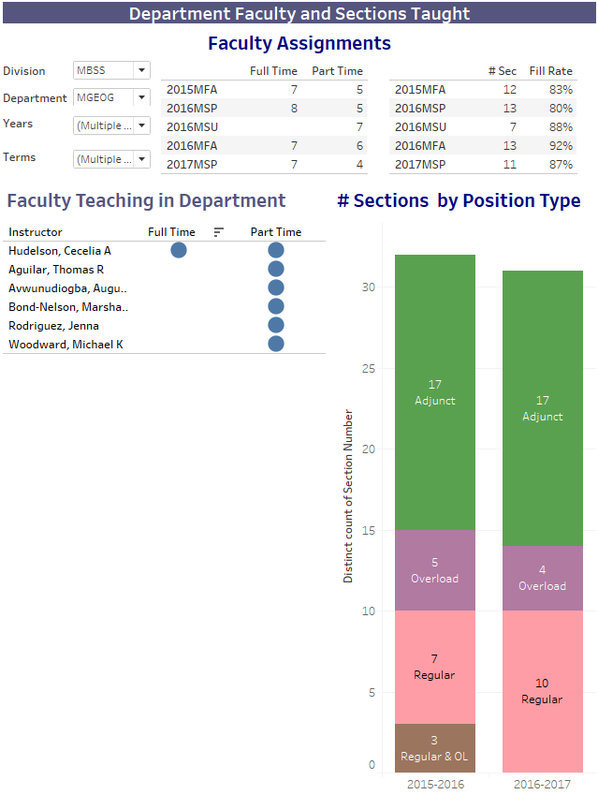
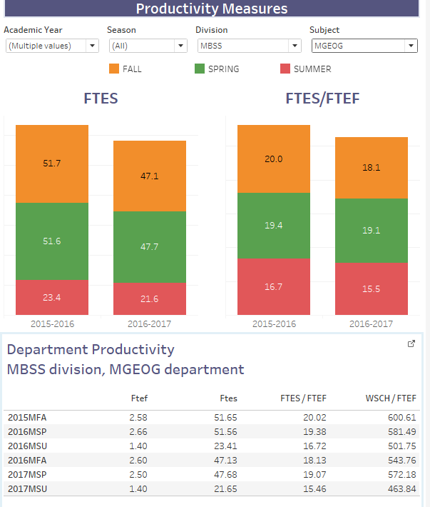

Long Term Planning and Resource Needs

Long Term Planning
Provide any additional information that hasn't been addressed elsewhere in this program review, such as environmental scans for opportunities or threats to your program, or an analysis of important subgroups of the college population you serve.
View the Program Review Instructions page for reference and inspiration.
Taking into account the trends within this program and the college, describe what you realistically believe your program will look like in three to five years, including such things as staffing, facilities, enrollments, breadth and locations of offerings, etc.
Hopefully, in the next 3-5 years, Geog 111, the physical geography lab course will be in full operation. It has been offered in two semesters and has C-ID approval, yet students are not aware of the course. Cece has taken a proactive approach this fall talking directly to many counselors to encourage enrollment and it will be offered again in Fall 2018. We hope to have more adjunct faculty on staff to cover the 6 preparations, and enable us to offer a greater variety of course modalities and locations. Geography will continue to grow in enrollment as Guided Pathways articulate direct connection to UC and CSU requirements. Liberal Studies populations (who take geography) should increase as K-12 jobs are projected to increase due to the retirement of baby boomers currently teaching.

Resource Request and Action Plan
Priority | Name | Resource Type | Estimated Cost | Objective
1 | Lab materials |  | 2- 5,000 | Facilitate instruction in Geog 111

Evaluation of Previous Resource Allocations
Below is a list of resource allocations received in previous Program Reviews. Please evaluate the effectiveness of the resources utilized for your program. How did these resources help student success and completion? (https://www.mjc.edu/governance/rac/documents/ielmallocationsummary20142015.pdf)
The Evaluation / Measured Effectiveness can be typed in another program and pasted here, or typed directly in to the box below. The box will expand with additional text, and paragraphs (hard returns) can be added by using Ctrl+Enter.
Resource Allocated | PR Year | Evaluation / Measured Effectiveness
$4500 - smart boards for group simulations | 2016 | Not yet purchased or installed

Appendix

Optional Questions
Please consider providing answers to the following questions. While these are optional, they provide crucial information about your equity efforts, training, classified professional support, and recruitment.
What strategies do you use to recruit, support and retain students from disproportionately impacted groups?
Geography courses celebrate ethnically diverse classrooms! We would love to see a higher number of students from disproportionately affected groups so that 1-2 students do not skew our data and would give us more concrete data to facilitate success and student equity. Geography courses will employ more student presentations in order to engage students from disproportionately impacted groups.

Does your division (or program) provide any training/mentoring for faculty to support the success of students at risk of academic failure?
Somewhat, yet we need to hear more fully about strategies which demonstrate success with students at risk.

Is there a need for more classified professional support in your area, please describe this need. Indicate how it would support the college mission and college goals for success, and completion.
No

What factors serve as barriers to recruiting active faculty to your program(s)?
It’s geographical. CSU Stanislaus is the only program with a Master’s degree in our region, creating a limited pool of adjunct faculty. Our hourly pay for adjuncts is not high enough to entice faculty from UC Berkeley, CSU San Francisco or CSU San Jose to drive in for a class.

Review Process Feedback
Please share any recommendations for improvements in the Program Review process, analysis, and questions. Your comments will become part of the permanent review record.
It would be great if we could click directly on section data to disaggregate by ethnicity and success.

Executive Summary
Provide an executive summary of the findings of this program review. Your audience will be your Division Program Review Group, the MJC Program Review Workgroup, and the various councils of MJC.
The Geography department is a strong one person program. We currently offer over 30 sections of geography per year, and have over 5 adjunct faculty on staff. Geography courses fulfill both natural science requirements and social science requirements for transfer. We have recently added a Physical Geography lab course to mirror state C-IDs. Our success rates have improved by 6% over the past two years. Most of this success is due to moving from large lecture courses to single sections where students feel more connected to the instructor. Over half of our sections are offered online as student demand has created strong waitlists. Geography courses are offered in 16 week, 8 week, and 5 week formats in order to adjust to student need and enrollment goals for the college.

