Modesto Junior College
Agriculture Department
Fall 2018 Student Internship
Resident Application
2018 Application
Application Deadline: Postmarked by Monday, May 7, 2018
(Interviews: Week of May 14 [if needed]. Announcements of Residence: Week of May 21, 2018)

West Campus Housing
Modesto Junior College
Agriculture & Environmental Sciences
Resident Application
2018
Application Deadline: Postmarked by Monday, May 7, 2018

Please Provide the Following with Your Application:
- Personal Essay
  - State your reason for requesting residence for the Student Internship Housing.
  - Include a brief history of your background that encompasses your agricultural experiences, activities, work experience, and achievements.
  - Expound upon your future educational and career goals.
  - Limit this statement to two pages.
- Resume
- Copy of Your Driver’s License
  - All Student Interns MUST have a valid California Driver’s License to be able to operate school machinery and drive school vehicles.
- Copy of your High School/College Transcript
- Two Current Letters of Recommendation
  - Both ‘Letters of Recommendation’ must be dated after January 1, 2018.
    - Provide one letter from a school-related source.
    - Provide one letter from a non-school related source, (i.e. work supervisor, church leader, community organizations, etc.)
    - Please no letters from friends or relatives.
Please send your application to the following address:
Mr. Troy Gravatt, Professor
Agriculture & Environmental Sciences Division
Modesto Junior College
435 College Avenue
Modesto, CA 95350-5808

If there are any questions regarding the Internship Application, please contact:
Troy Gravatt
Office: (209) 575-6790
gravattt@yosemite.edu

Modesto Junior College
Agriculture & Environmental Sciences
Resident Application
2018 (continued)
Application Deadline: Postmarked by Monday, May 7, 2018

Name: ________________________________________ MJC W#: _______________________ Date:
Home Phone: __________________________________ Cell Phone:
Email: ____________________________________ Driver’s License Number:
Mailing Address:
City: ________________________________________ State: _______________ Zip Code:
High School: __________________________________________ Town:
Semester/Year Planning to Enter MJC: _____________
Please mark your top three choices in order of priority (1 to 3, 1 highest):
______ Ag Business / Division Office ______ Mechanized Ag Unit
______ Beef Unit ______ Nursery Unit
______ Crops Unit (Orchard & Vineyard) ______ Poultry Unit
______ Dairy Unit ______ Power Mechanics Unit
______ Equine Unit ______ Sheep Unit
______ General West Campus ______ Swine Unit
______ No Preference

Please list any MJC Staff/Students that you know:

MJC Staff Contacts: MJC Student Contacts:
1. ___________________________________________ 1. ___________________________________________
2. ___________________________________________ 2. ___________________________________________
3. ___________________________________________ 3. ___________________________________________
Modesto Junior College
Agriculture & Environmental Sciences
Resident Application
2018 (continued)
Application Deadline: Postmarked by Monday, May 7, 2018

List Three References:
- Name:
Position/Title:
Address:
City, State, Zip:
Business/Work Phone: Cell:
Email:
- Name:
Position/Title:
Address:
City, State, Zip:
Business/Work Phone: Cell:
Email:
- Name:
Position/Title:
Address:
City, State, Zip:
Business/Work Phone: Cell:
Email:
Modesto Junior College
Agriculture & Environmental Sciences
Resident Application Schedule
2018 (continued)
Application Deadline: Postmarked by Monday, May 7, 2018

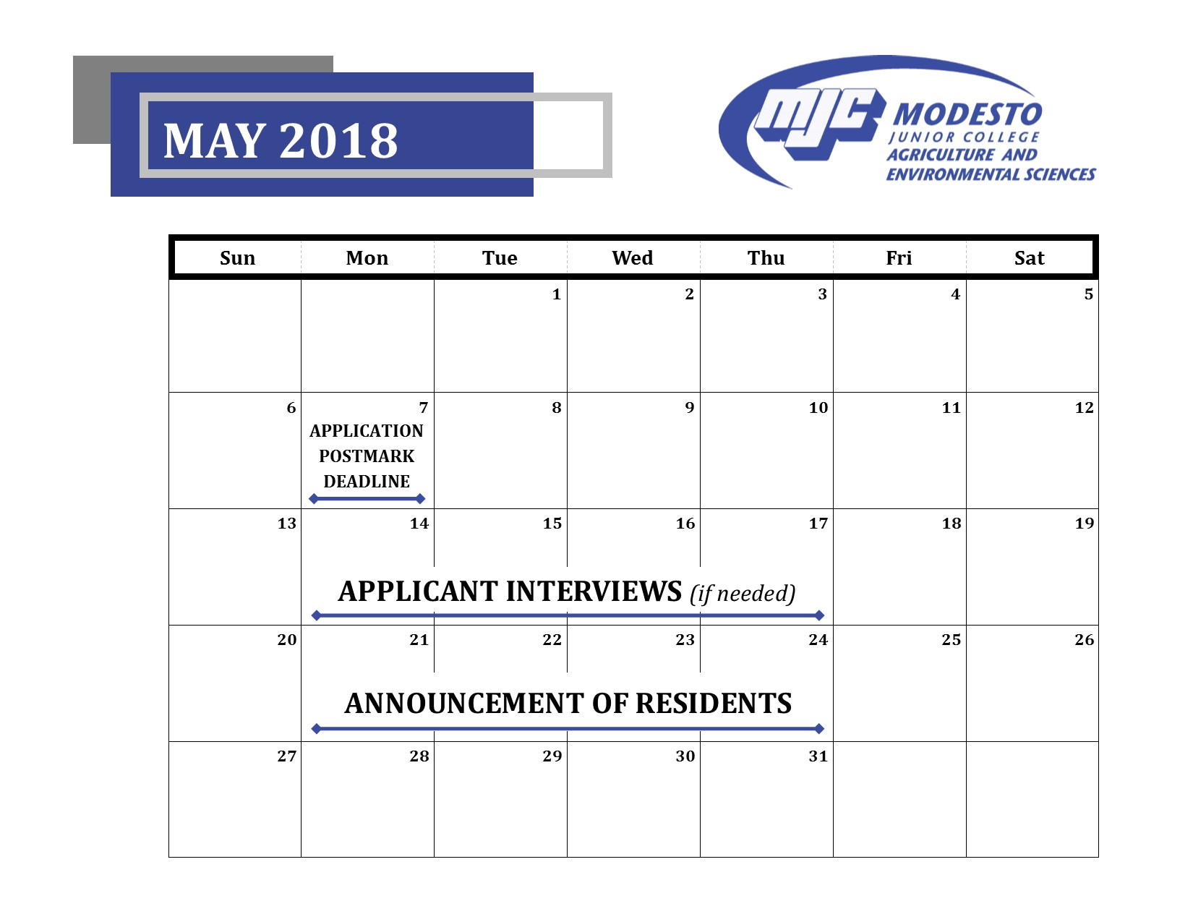

Thank you for your interest in the
Modesto Junior College Agriculture Department
“West Campus” Student Internship Resident Program!

